LEAVING THE CITIES
Source A – Information from the Imperial War Museum

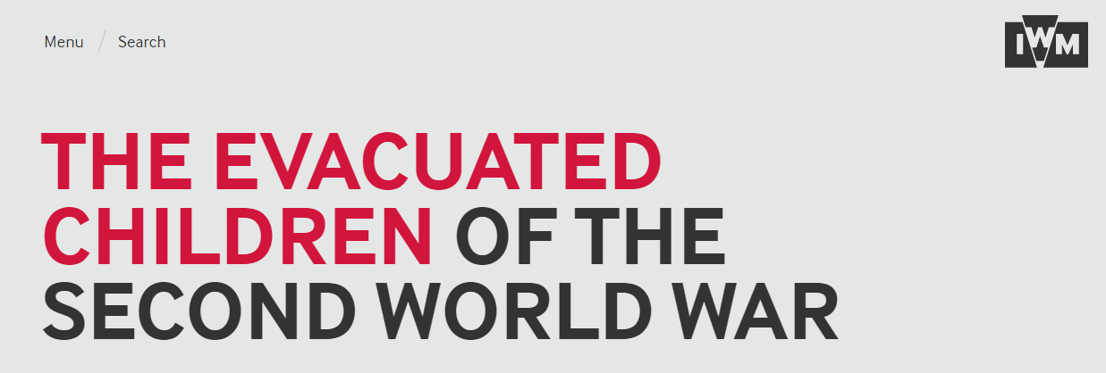

Children were evacuated from cities across Britain. The children in this photograph are evacuees from Bristol, who have arrived at Brent railway station near Kingsbridge in Devon, 1940. Parents were issued with a list detailing what their children should take with them when evacuated. These items included a gas mask in case, a change of underclothes, night clothes, plimsolls (or slippers), spare stockings or socks, toothbrush, comb, towel, soap, face cloth, handkerchiefs and a warm coat. The children pictured here seem well-equipped for their journey, but many families struggled to provide their children with all of the items listed.

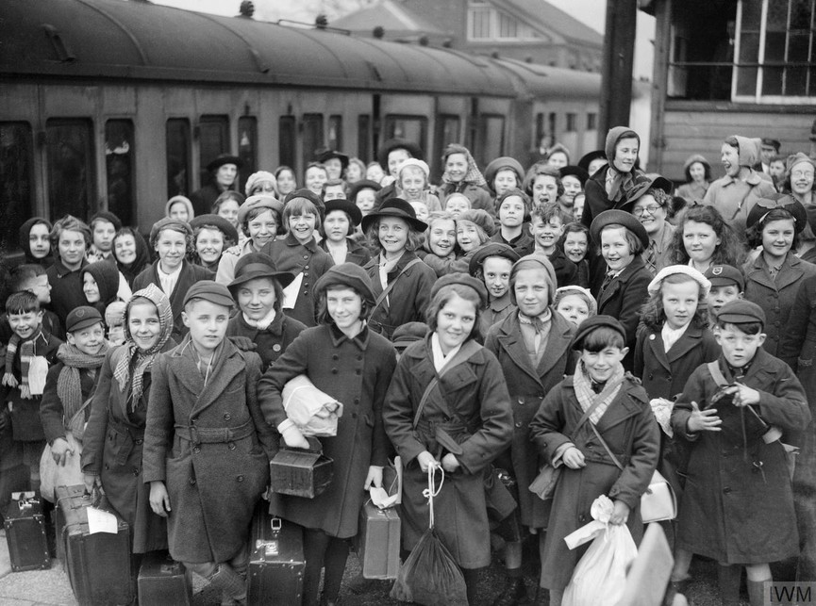

Source B – A clip art picture of a suitcase from Twinkl

Source C – Ministry of Health (Government) leaflet

 | GOVERNMENT EVACUATION SCHEME
TO PARENTS OF SCHOOL CHILDREN

The Government have decided that parents of schoolchildren
in this area are to have the opportunity of sending their
children away to a safer district while present enemy
activity continues. If you wish your children to go with
the organised scheme, please fill in the form attached to
this notice and get your child to bring it to school.

Arrangements to be made.

1.Clolthing Your child should take the following in
addition to what he or she is wearing, and all articles
must be darned and mended. If any of these articles cannot
be provided please notify the teacher at once.
 | BOY.  2 vests.  2 under pants.  2 shirts.  2 pyjamas and night shirts.  2 pair socks.  2 pairs boots or shoes.  1 Wellingtons (if possible).  1 warm coat and/or mackintosh.  (if not being worn).  1 pair knickers or trousers.  1 pullover.  6 handkerchief.  1 toothbrush.  1 face flannel.  1 comb.  2 towels. |  |  | GIRL.  2 vests.  2 liberty bodices (if worn).  2 knickers.  2 nightdresses or pyjamas.  2 pairs of socks or stockings.  2 pair shoes  1 Wellingtons (if possible).  1 warm coat and/or mackintosh  (if not being worn).  1 warm dress or tunic and  jersey.  1 cardigan.  2 cotton frocks.  6 handkerchiefs.  1 toothbrush.  1 face flannel.  1 comb.  2 towels.
Gas mask
Identity card
Ration book
Clothing and personal coupons
2. You will wish to do everything possible to ensure that your
child goes away with clean clothes, clean hair and a clean
body.

3. Luggage. The child should wear this warmest and thickest
footwear. The inventory above is to taken as minimum
requirements, but do remember that your child should not be
taken more than he can carry comfortably.

4. Food. Each child should take sufficient food for one day.
Be sure your child has his ration book and if pages of
coupons out of his book have been deposited with retailers,
ask for their return and pin the loose pages in the ration
book. Your child's ration book, identity card and personal
coupons should be paced inside the gas mask case.
PLEASE keep this notice for reference and return the form to
your child's school immediately if you want him or her to take
part in the evacuation scheme.

