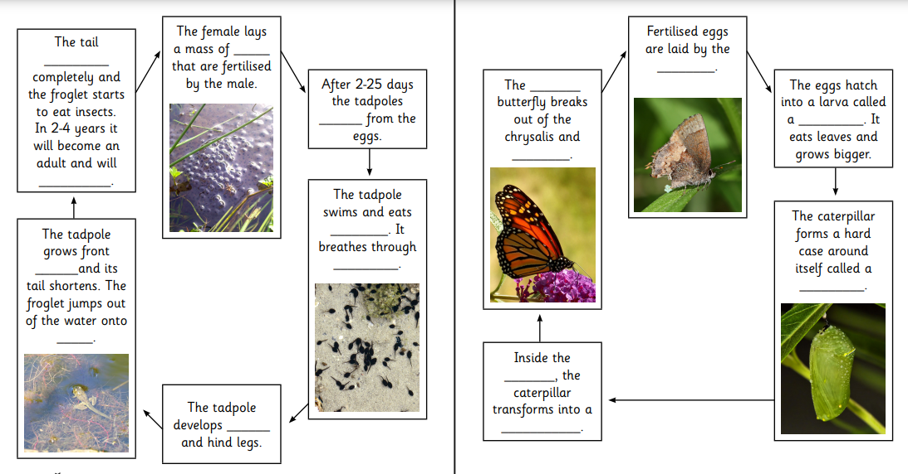
Amphibians and Insects - use the information in the powerpoint to fill in the missing information

