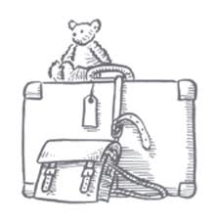
Comprehension Questions - Chapter 7

1. Why do you think that Aunty Lou went to visit her friend? (Page 86, 95, 67)
2. How have Nick’s chilblains healed? (Page 87, 96, 68)
3. Why was Albert taught on his own sometimes? (Page 87, 97, 68)
4. Which word on page 88, 97, 69 tells us that Mr Johnny and Nick went on trips together?
5. Why was it strange for Mrs Gotobed to be wearing a lavish dress? (Page 90, 99, 70)
6. What colour eyes has Carrie got? (Page 89, 99, 69)
7. Mrs Gotobed wants to wear each of her dresses one more time before she dies. What does this suggest? (Page 90, 100, 70)
8. How do we know that Nick really enjoys his time at Druid’s Bottom? (Page 95, 105, 73)

Answers
- To get better.
- From the magic ointment that Hepzibah has given him.
- Because he was cleverer than the other boys in his year.
- excursions.
- Because Mrs Gotobed was ill so we wouldn’t expect her to be dressed in fine clothes.
- Green
- It suggests that she knows that she is going to die soon.
- He keeps saying, “It’s my best thing.”

