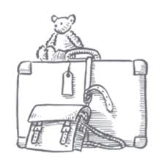
Comprehension Questions - Chapter 7

1. “January snowed itself out.” What does this suggest? (Page 86, 95, 67)
2. Why do you think that Carrie told Nick that he should not tell Mr Evans that he’d seen a calf being born? (Page 87, 96, 68)
3. How was Albert different to the other children? Find two pieces of evidence. (Page 87-88, 97, 68)
4. Which phrase on page 88, 97, 69 tells us that Mr Johnny and Nick ventured out a lot together?
5. Why do you think that Carrie was horrified at the suggestion that she keep Mrs Gotobed company? (Page 89, 98, 69)
6. What colour eyes has Carrie got? (Page 89, 99, 69)
7. Mrs Gotobed wants to wear each of her dresses one more time before she dies. What does this suggest? (Page 90, 100, 70)
8. On page 94, 104, 73, Carrie describes Mrs Gotobed as solemn. What synonym could you use for this word?
9. “I’ve done what I’ve done because it seemed to me right…! What do you think that Mrs Gotobed has done? (92, 102, 71)

Answers
- That it snowed for a lot of January but gave up towards the end.
- She knows that if Mr Evans thought they were having a good time then he probably wouldn’t let them go again.
- Because he was extremely bright, he was sometimes taught alone. He wasn’t stuck up or bothered by age. He continued to be friends with Carrie and Nick even in front of the senior boys.
- Often went on excursions.
- Albert told Carrie on their first visit that Mrs Gotobed was dying and she’s been frightened ever since.
- Green
- It suggests that she knows that she’s going to die soon.
- Sincere, dignified
- Left Hepzibah Green the house or her money in her will.

