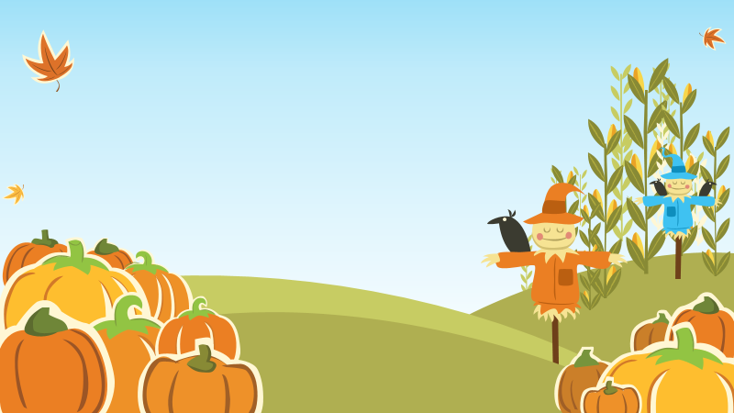

Super stars 



Congratulations to our new Reception children who have all made a super start.

Well done!



A big thank you to all of our parents and carers. We have really appreciated your patience and support in making the morning leave successful. *Remember, as soon as your little one is settled, it is time to say a quick goodbye and leave them to enjoy their exciting day!*

7th September 2018  Term: Autumn 1 Week: One

## Reception Class Newsletter

Welcome to the start of a new school year! We hope you had a lovely summer break and are looking forward to the exciting year ahead.

In Reception, a weekly letter will be sent out to let you know what your child has been focusing on each week. Children are sometimes reluctant to talk about their day so this will hopefully help to give you an insight. The letters may also include reminders of special events or requests for things to be sent in.

The children have all been busy settling in this week and have been learning the new school routine. They have coped really well and have been excited to use different areas of their setting. They have been keen to get to know one another and it has been lovely to see some friendships beginning to form.

We have talked about the golden rules and why it is important to have them. The children thought about how we should treat others and how someone might feel if they had been hurt.

We have also spent a lot of time using the outdoor area. The children have loved using the scooters and pedal bikes. They tried hard to steer to avoid collision and enjoyed setting up traffic cones to make pretend roadworks like the ones they have seen in the local area.

Snack Reminders

Morning break has been enjoyed by your children this week. Please remember that **small snacks should be sent into school if your child does not have snack money**. Some of the children are bringing too much and are not having time to eat it all and play. Snacks should be able to be eaten in 5-10 minutes leaving the children time to run around and have a play.

As we are a healthy school, can we also ask that snacks sent in for morning break are healthy. Please don’t send in chocolate bars and sweets. These should be kept as out-of-school treats.

*Many thanks in anticipation of your support*.

Make and do

The children are really enjoying the “Make and Do” area. We have completely run out of boxes and bottle tops for make and do. Please save and send in any suitable resources next week.

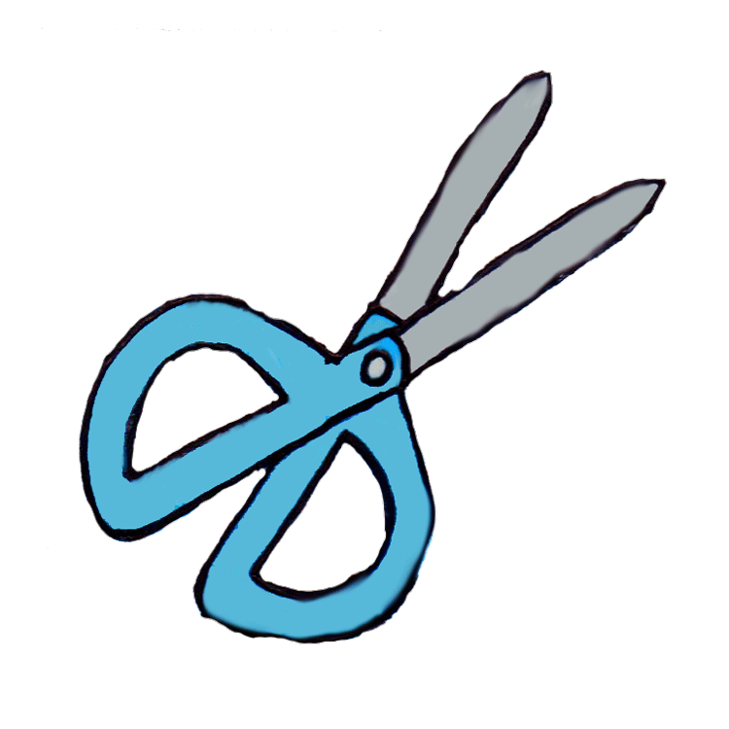

We cannot use medicine packets or toilet roll tubes for healthy and safety reasons.

*Next week we will be having a proper look through the treasure boxes brought in by the children. Thank you so much for your time and effort getting them ready.*

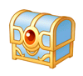

*Have a lovely weekend,*

*Mrs Rogers, Mrs Cheadle, Mrs Thompson and Miss Lewington*