Apples

27/3/20

**i spelt y**

myth

gym

Egypt

pyramid

mystery

hymn

system

symbol

lyric

typical

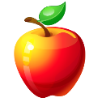

Pears

27/3/20

**i spelt y**

crystal

symbol

myth

typical

gym

mystery

hymn

pyramid

symptom

lyric

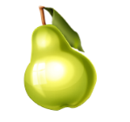

Oranges

27/3/20

**i spelt y**

symptom

oxygen

cygnet

calypso

mystery

syrup

crypt

typical

system

crystal

