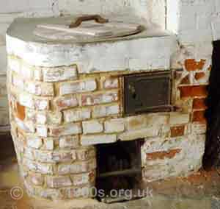
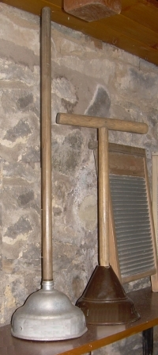
Answer sheet Victorian Laundry
←Possers and a wash board. Clothes were rubbed against the rough surface of the wash board to loosen the dirt.
The small posser would be used for hand washing and the larger one with the Dolly tub with a dolly peg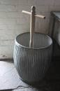

←Here is a Victorian Copper. It would be outside in the yard or in the Wash House. Families from a number of houses would work together to do all the laundry on Wash Day Monday.

Collect the sticks, coal to make a fire under the copper

Collect the water from the well in the yard by means of the pump

Fill the copper with water and light the fire to heat the water in the copper

Sort the clothes according to how dirty they are
Pay special attention to clothes that are stained & scrub them well
Scrub shirt collars with carbolic soap and laundry brush
Sort the white washing from the coloured washing
Use a bucket to fill the Dolly tub with hot water from the copper
Plunge and spin the clothes in the tub with the Dolly Peg
Transfer washed white clothes to the copper to boil to whiten
Re-fill Dolly tub from well with clean water and add Dolly blue
Rinse clothes thoroughly using a posser or Dolly peg
Repeat this until the clothes are free of soap
Put the clothes through the mangle to squeeze out the water
Peg the clothes on the line to dry
Transfer clothes from the copper to the Dolly tub
Rinse clothes thoroughly using a posser or Dolly peg
Repeat this until the clothes are free of soap
Put the clothes through the mangle to squeeze out the water
Mix Colmans cold water starch
Dip pillowcases and cuffs and collars in Starch for crisp appearance
Peg the clothes on the line to dry
Use the water left over in the copper to clean the floor
Heat the flat irons on the fire
Put a blanket on the scrubbed table ready for ironing
Iron clothes
Air the clothes in-front of the fire
Well done everyone. I hope you had fun doing this. *This answer sheet used many of the tasks twice just to show how time consuming it all was because coloured clothes had to be washed separately from the white. They all had to be rinsed very well in order to keep the white washing white. * we did not expect you to do this. You could decorate the sheet if you wish. Some people would leave the washing of the floor until the end of the day others may prefer to do it earlier when the water from the copper was still hot.
How easy it all is today with electric washing machines. How lucky we are to do this work sheet on the computer – just think if you were doing it using a dip pen like the Victorian children. Let us be thankful for the progress that has been made.

