The Himalayan Herald

22.04.2001

Unidentified Footprints found in tourist hotspot

Reported by A.McArdle
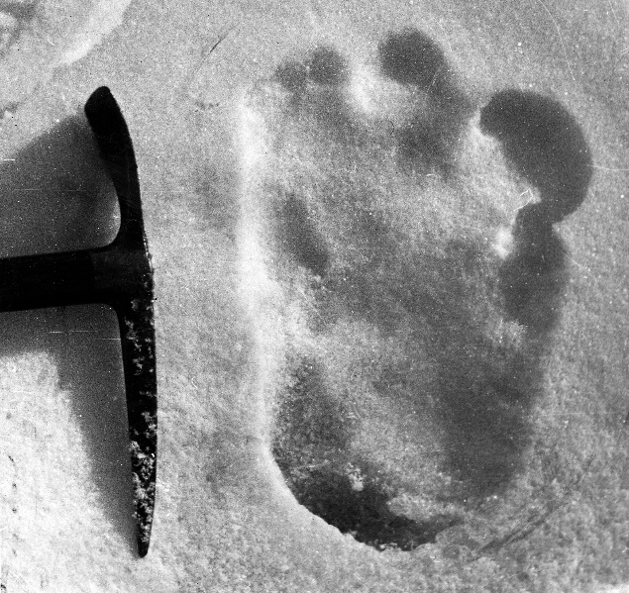
YESTERDAY afternoon, a 32-year-old man from Dorset, England along with his 33-year old girlfriend reported stumbling across a track of extraordinarily large footprints just below the summit of Mount Nanvi Dar whilst climbing for pleasure.
Mr Ethan Wallace and partner, Miss Jade Spicer, had been staying at the Hotel Himalaya – a popular destination for anyone wishing to climb the most perilous mountain in the world. Hotel manager, Mr Brian Goodling, stated that the young couple had left that morning fully kitted out for their day’s climb. He hadn’t expected them to arrive back from the trek until much later on that evening and was completely shocked when they burst back through the doors at around 2 pm. “I initially assumed that there had been an accident,” the 52-year-old reported. “I couldn’t understand why they were back so soon! It was only after the pair had calmed down that we were able to fully comprehend the significance of their return. ”
Footprint left by the mysterious creature – photographed by Mr Ethan Wallace who discovered the prints
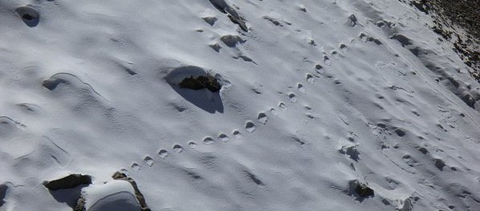
The two mountaineering experts recall the moment they discovered the tracks as being one of the most terrifying experiences of their lives. Veterinary nurse Ethan Wallace reported that he and his girlfriend, a mechanical engineer from Lincolnshire, had been planning their once in a lifetime trip to the Himalayas for over a year and were truly excited to be completing the summit trek that day. He said that after a short rest upon a remote path near the mountain’s peak, they began to embark upon the final stretch of the climb when they came across a strange shape in the snow. Closer inspection revealed a
Clear photograph of the single file track of unidentifiable footprints taken by mountaineer Ethan Wallace.
trail of single-file footprints that were mere yards away from an impassable chasm. The animal lover claimed that the tracks seemed to wind their way down to the left of the path in which they were on although appeared to begin out of nowhere. “We were both utterly shocked and frightened when it became clear that these were in fact huge animal footprints. They were so large. We were worried that the beast was lurking nearby and feared for our lives.”

