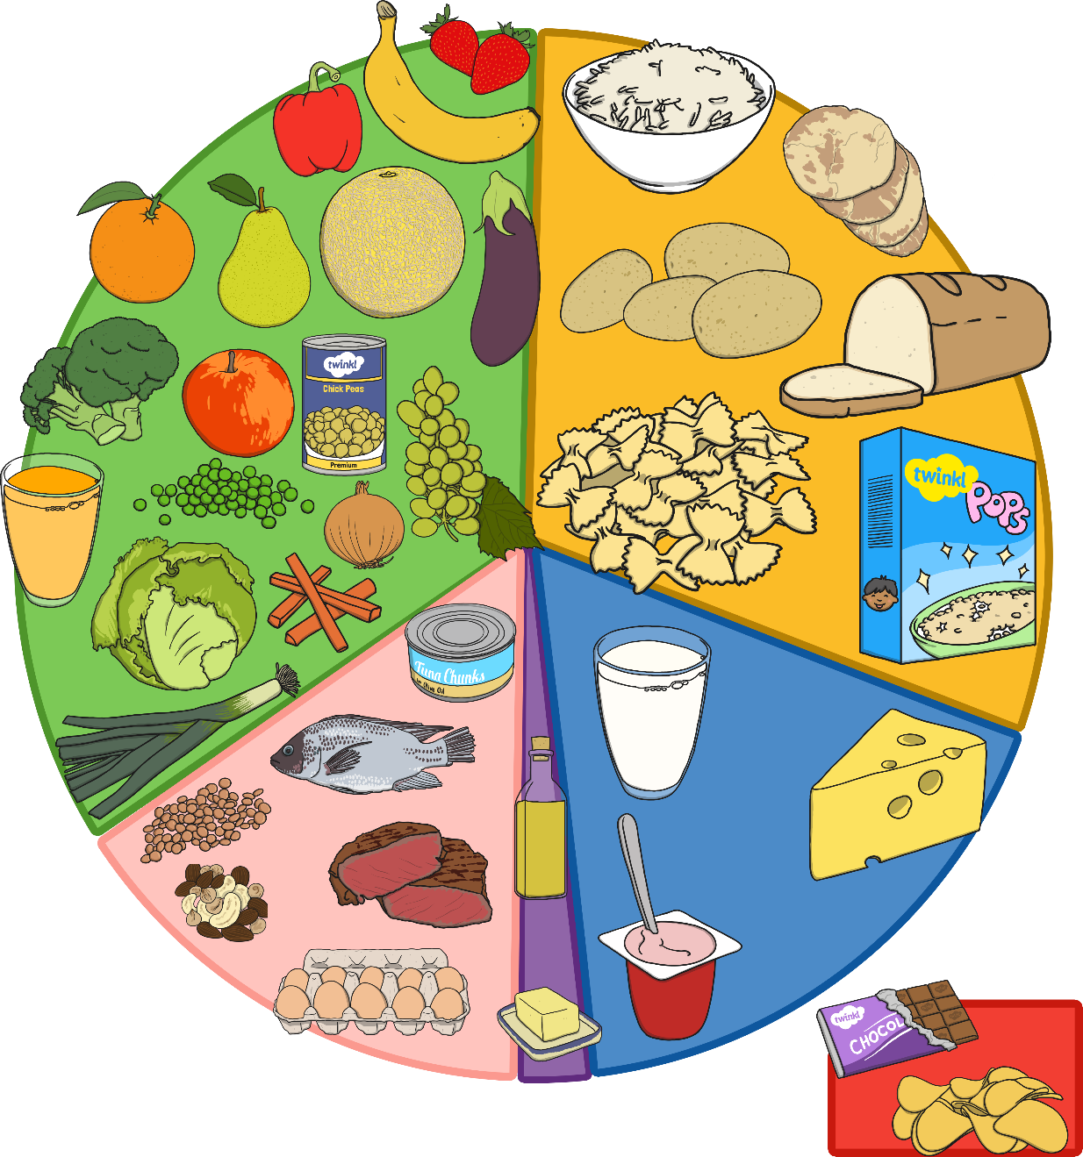
Label each section (group) of the plate according to the types of foods that ae in each section.
fruits and vegetables | meat, fish, eggs, beans  and other non-dairy  sources of protein | bread, rice, potatoes, pasta and other starchy foods
oil and spreads | milk and dairy products | food and drinks high  in fat and / or sugar

B
D
F
E
C
A
A) fruits and vegetables
B) meat, fish, eggs, beans and other non-dairy sources of protein
C) bread, rice, potatoes, pasta and other starchy foods
D) oil and spreads
E) milk and dairy products
F) food and drinks high in fat and / or sugar

