Victorian Silhouette Portraits.
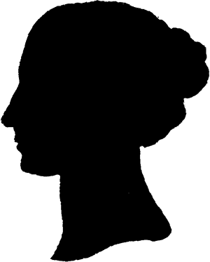

You will need a pen or a pencil, a piece of A4 paper (black), a piece of A4 paper (white), a piece of A4 paper (any colour) and scissors.

- Choose a room where there is a wall with plenty of space around it.
- Switch the light on in the room.
- Stand near to the wall so that you can see your shadow on the wall.

You will need help with this part so find somebody to draw your silhouette.

- Your helper needs to hold the piece of white paper against the wall and you need to stand near the wall so that the shadow of your head is on the piece of paper.
- Your helper will then draw around the outline of your shadow. BE CAREFUL! Make sure they are only drawing on the paper!
- Using scissors, cut out the outline of your silhouette.
- Place the white paper silhouette onto the black paper. To make it a little easier, you may need to use a paperclip to hold the paper or a different coloured pen to draw around the silhouette.
- Using the white paper silhouette as a template, cut out another silhouette.
You should now have two silhouettes- 1x white paper and 1x black paper.

- Stick the black paper silhouette onto another piece of paper of your choice. You now have a Victorian silhouette portrait!

