Let’s Have Some Fun Looking at Flat Irons
Flat irons came in different shapes and sizes.
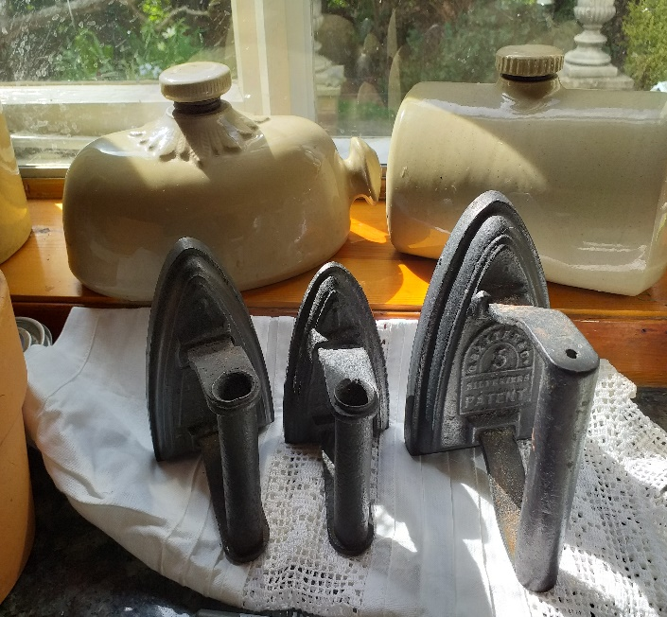 Any idea why they had numbers on?
What do you think the stone bottles behind were? Here is a clue- the one at the museum has the letters B E D on?
Back to the flat irons – What do you notice about these two irons? What is different about them? 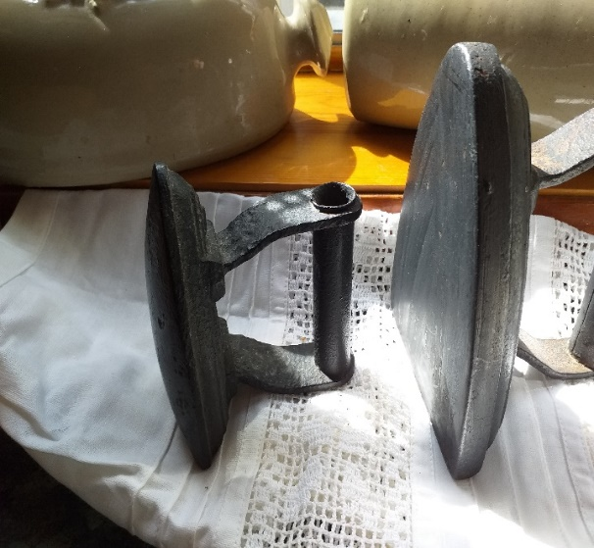

Here is another different one. What happens if we raise the bar using the brass top?
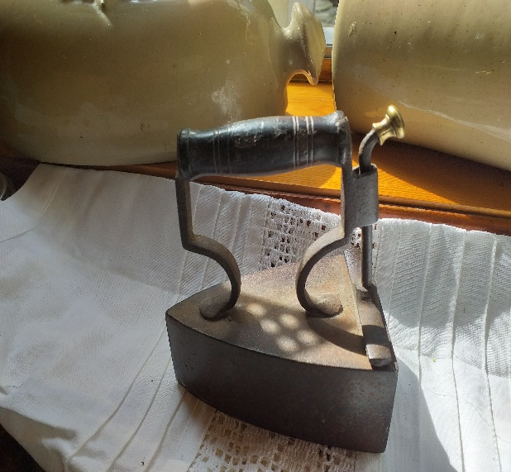 What is sliding out of it? 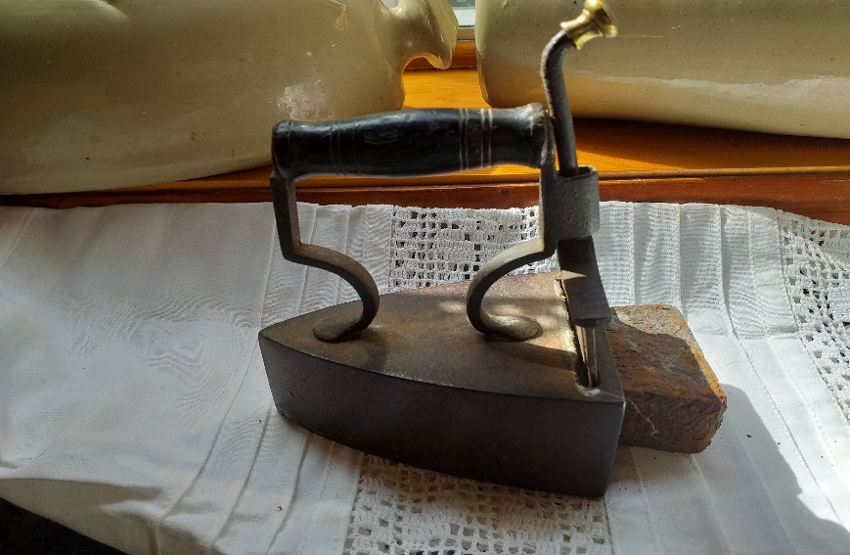

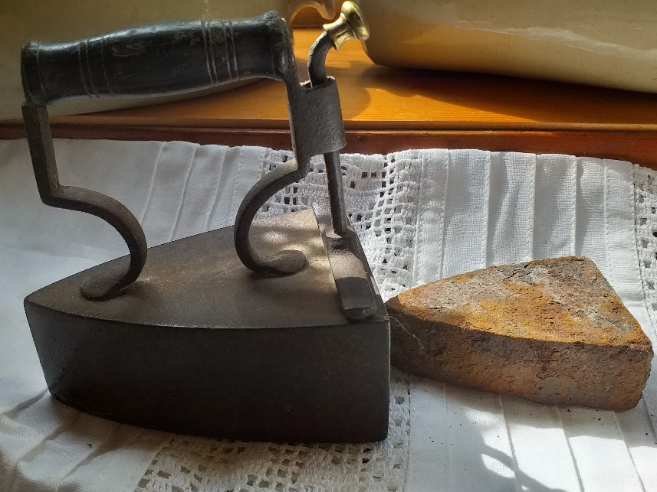What is the point if this?
Whatever are these extra-large and very heavy ones used for?
