Flat Irons Help sheet
The numbers on the irons related to their size. The smallest irons being used for baby clothes and small parts of garments like sleeves.
Flat Irons were also called Smoothing irons because they smoothed out the creases. Sometimes they were called Sad irons because they were so solid.
Flat irons were made of cast iron and it lasted a very long time. Ones that are still around now tend to be rather rusty.
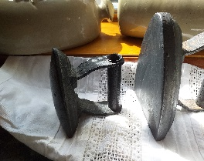
The smallest iron has a round bottom!
Why did an iron have a round bottom? Because it was especially for the inside of Top Hats and Bowler Hats.
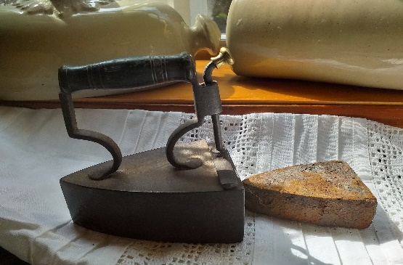
This iron was often called a Tailor’s iron because it was used by people who made formal suits and frock coats. It was also know as a box iron and the stone was called a Slug
The slug was heated in the fire as a way of heating the iron. Irons were used in twos- one actually for ironing and the other one heating up on the fire ready for use when the first one cooled down.
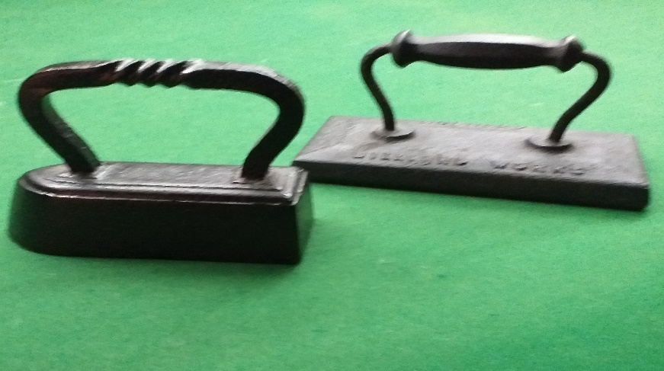
These irons were Billiard Irons and were used when cleaning and caring for billiard and snooker tables. You can watch a video of them in use on Utube if you google Billiard Irons. I hope you enjoy sharing these with your family and friends. Your Grand parents will probably be able to tell you a lot more about Flat Irons.

