This week’s worksheet follows on from “How Schools have Changed” from last week.
Curriculum links: Social history, English – thinking skills, vocabulary and discussion, Design and Technology – materials.

Thinking of the School Day that we looked at last week here are some further interesting thoughts.
What do you think you might have had for breakfast before trudging across the fields to school or work all that long time ago?

Which of these would you have been using all that long time ago?
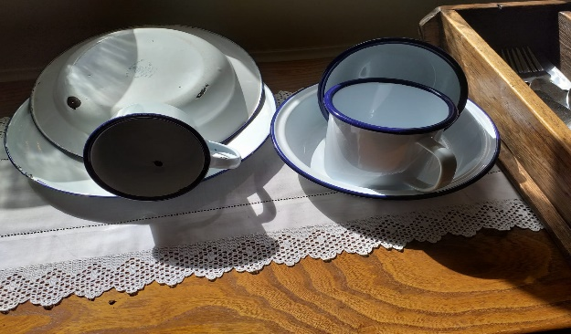 OR These?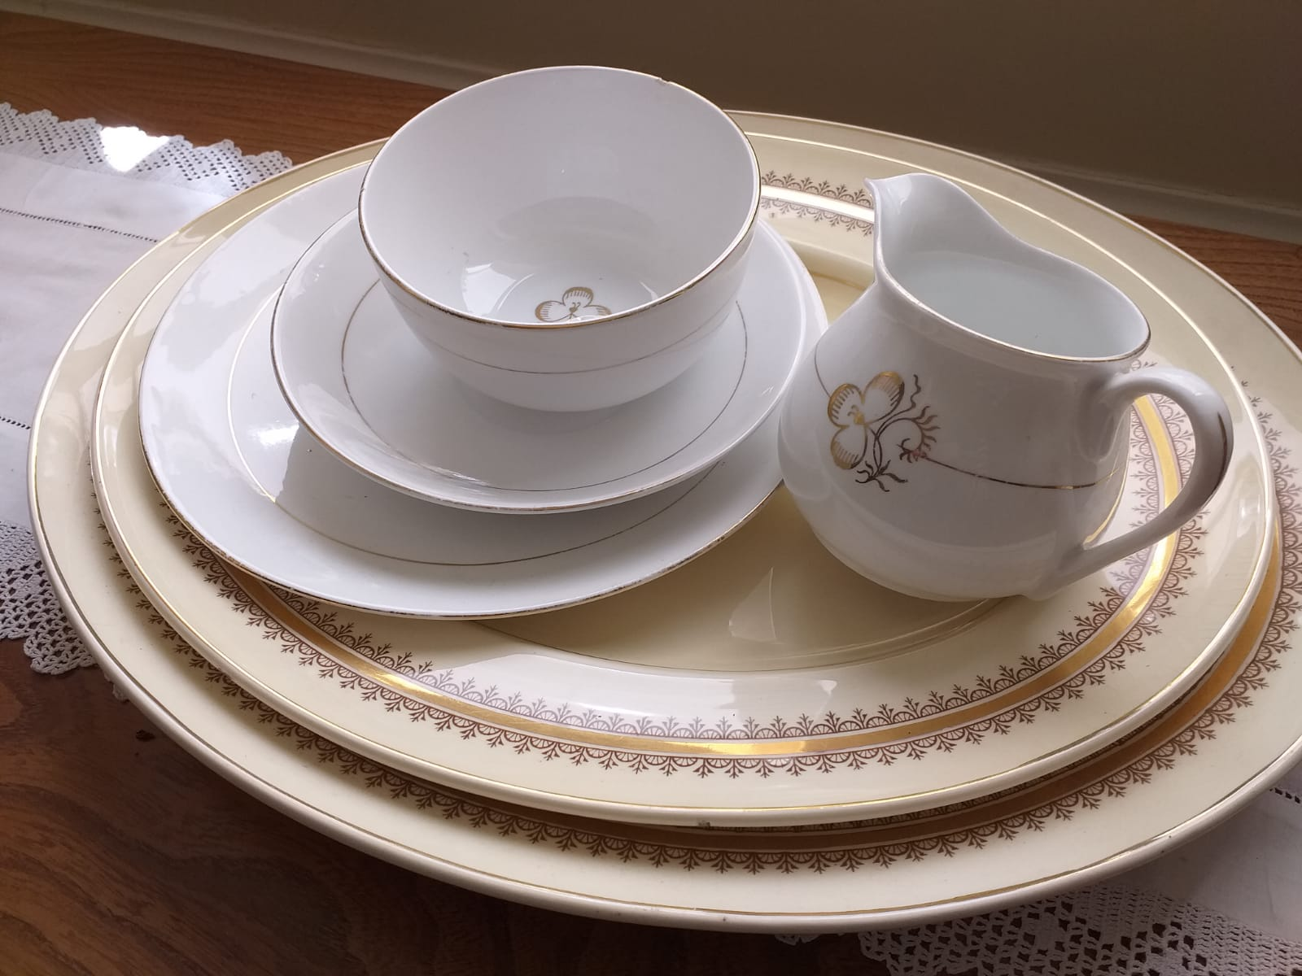

What are the items made of?
What do you think are the main differences between the two materials?

Why did it matter what they were made of in those days?

Your family may be able to tell you things they remember about the things they ate or used a long time ago.
Some of these are genuine old pieces of crockery (a name sometimes used for cups, saucers & plates etc.) Can you tell which is which? 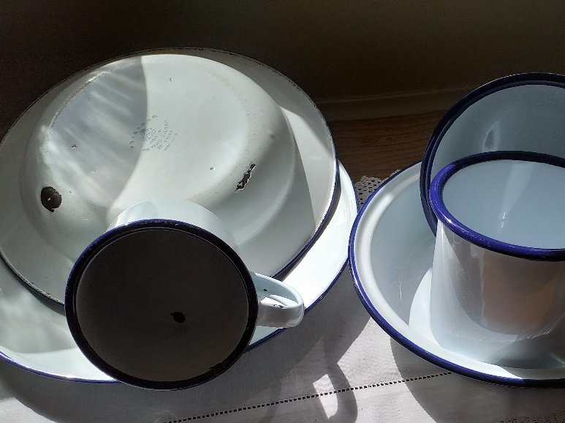

Where do you think these would have been used? 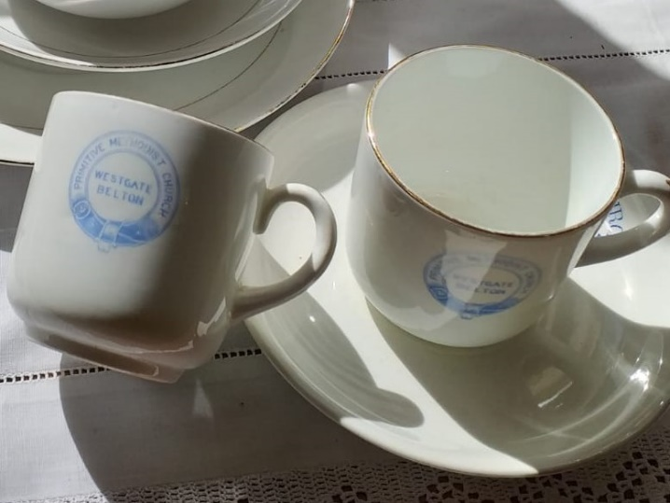

Friday this week is a special Bank holiday because it is Victory in Europe Day, or VE Day, which marks the 75th anniversary of the end of World War II in Europe. It will be the first day of a long weekend of remembering events that took place 75 years ago across the country. Ask the older members of your family about them and they will probably have some songs that they can tell you about – possibly over the phone if you cannot meet them at present.
Here are some hymns, worship songs that you would have sung at Sunday school. Perhaps you can sing them with your family or play the tunes on your recorder, piano or guitar etc.
Some of you who have visited the museum will remember singing Hear the pennies dropping as you marched and put Victorian pennies in the missionary box.
Keep safe and have a good sing song.

