Sunday Schools Within Living Memory
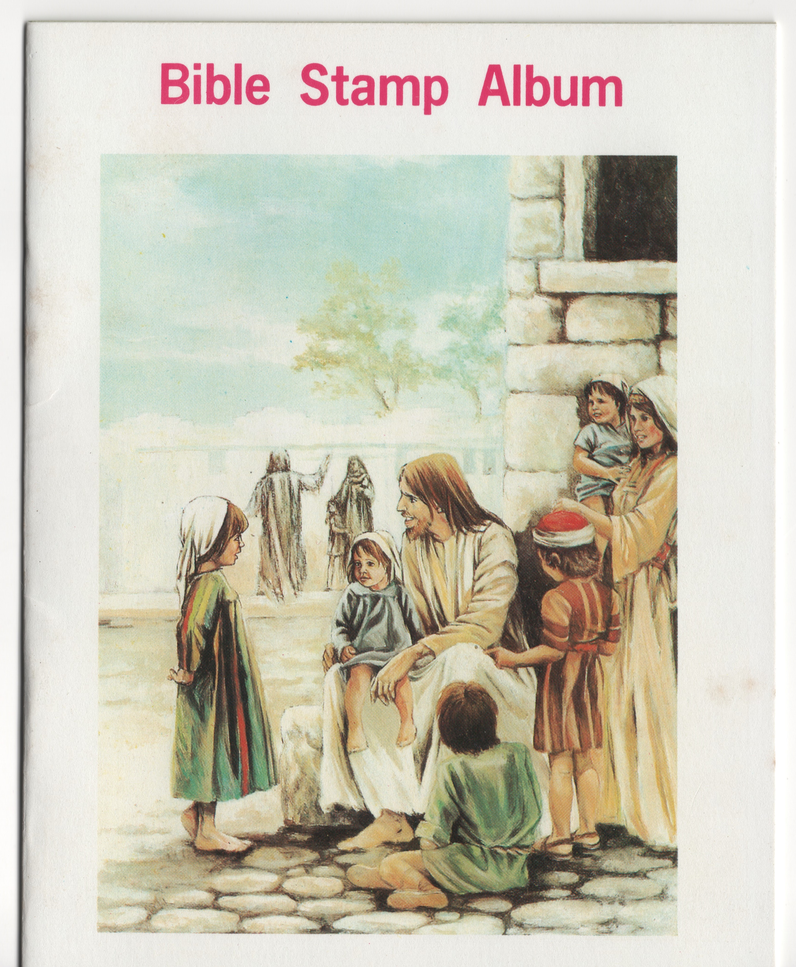
Many years ago, children were encouraged to go to Sunday school regularly and were rewarded for attending each week, by receiving stamps to stick in their special Sunday school album. Children were given special stamps to put in their album and by attending every week they could complete all the pages. The stamps were linked to the bible stories the children had been learning about in their Sunday school class.
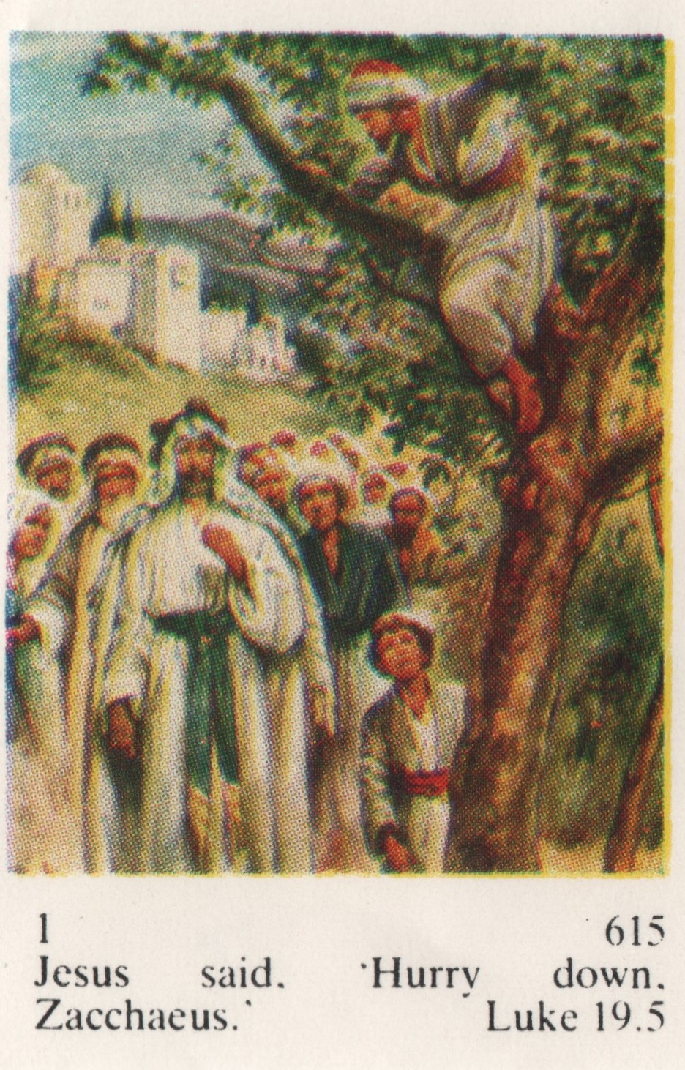

Do you have a favourite bible story? Perhaps you could design a stamp telling your favourite bible story or a picture of your family or special occasion.
You might like to do this using pencils, sharpies, paint or even a computer.

The stamps were stuck into the albums week by week. Do you know which bible story this page is all about? The numbered spaces tell the children where to put the different numbered stamps.
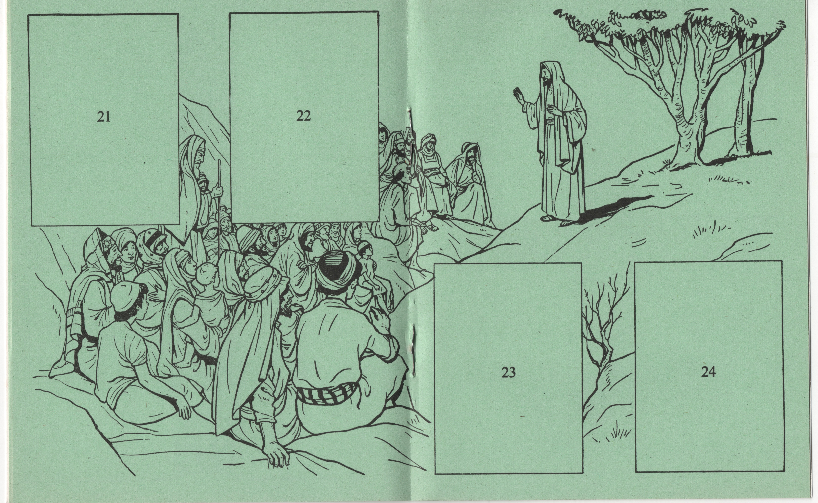
At Sunday school a collection of money was taken and children gave, whatever their family could afford, and they put the coins in a Missionary Box. This money helped to pay for a minister to go to places far away like Africa, so that they could tell the people there, all about God.
At Englesea Brook Chapel and Museum we have many interesting things that these ministers, know as Missionaries, brought back to England. We have wonderful things from Africa, China and India and you can learn all about them when it is safe again to visit.
When the children put their coins in the missionary box, they marched up and down the Sunday school hall singing `Hear the pennies dropping`. The second verse of this hymn or worship song tells the children `If there is no penny you may bring your love`. This was particularly important in Victorian times when families were very poor and did not always have a penny spare to take to Sunday school. It was most important that they went to Sunday school every week or they would lose their place. If they lost their place, they would not get educated because poor children could not afford to pay to go to school. In Victorian times, Sunday school was where the children learned about God but also this is where children of the poor learnt to read, write and do arithmetic.
In Victorian times there were great distinctions between poor people, know as the working class and rich people called the Upper class and those in between called middle class.
Here is a picture of a rich family in Victorian times. How many things can you see, that tell you it is a rich person’s house? What do you think about the quality of the picture? Do you know why it has so much dark colour round the border of the main picture?

