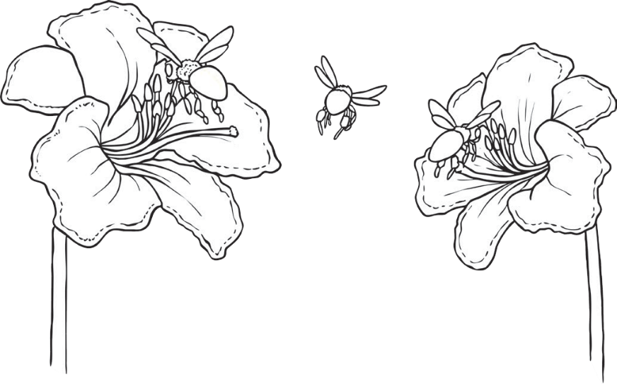Pollination

seeds

dispersed

ovule

ovary

**Word Bank**

anthers

fertilised

nectar

pollen

petal

stigma

Fill in the gaps.

1. The flower ‘s bright colours and fragrant scents attract an insect.
2. The insect arrives on the flower to collect .

This is a sweet liquid which makes perfect insect food.

1. As the insect is gathering the nectar it rubs against the

which rub on the insect.

1. When the insect gets hungry again, it gets attracted to another flower’s bright colours and fragrant scent.
2. As the insect feeds on the nectar in this new flower, the stuck to the insect from the first flower rubs off onto the female parts of the second flower (the ).
3. Part of this pollen travels down the style and then into the .
4. The tiny piece of pollen joins onto an

in the ovary. The plant has now been fertilised.

1. The ovary of the flower turns into which will then

be so that new plants will be able to grow somewhere else.