Magic Lanterns
Many, many years ago, when there were no moving pictures as we know them today, people watched magic lantern shows. The magic lantern and slides were used for amusement, when funny slides were shown and children watched stories told with the use of the magic lantern in Sunday schools. Sometimes these stories were light hearted such as the stories of `Cock Robin` and often they showed pictures of the times linked to stories that were often sad. We used to show the story of `Jack’s Little Treasure`, at the museum a few years ago. The picture of a rich person’s house in Victorian times was actually the last slide of that story.
We have already looked at some of the differences between poor and rich people during those earlier days and here is a magic lantern slide showing a lodging house; that is a house where people actually paid to spend a night in one of the rooms. Here Jack and his friend are saying their prayers before going to sleep for the night.
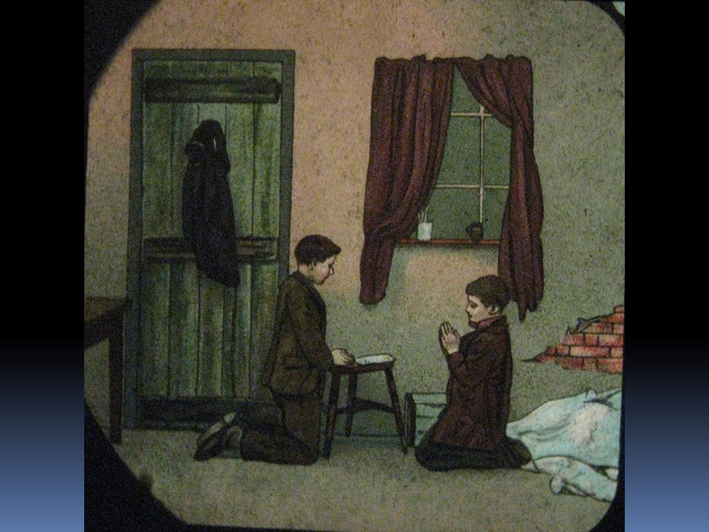
Can you remember how we can tell that this is a picture taken from a magic lantern slide? You can see the shape of the slide and then there is a lot of dark and blue colouring round the edges.

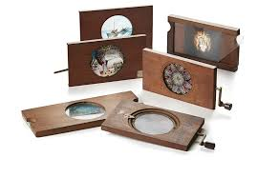
We have a variety of magic lantern slides at the museum.
Some really do look like action shots for instance, one has a man falling off a chair and another has the candle being blown out at the end of the day. The ones in the picture here have handles on them so that special effects could be used to make the whole thing even more amazing to the Victorians. Hopefully you will be able to visit and see them when the museum is open again and you can visit safely.
The magic lantern was also known by its Latin name, `lanterna magica`. Well it must have seemed like magic to the people all those many years ago. They would not have seen anything quite like it before.
Here we have a very elaborate magic lantern.
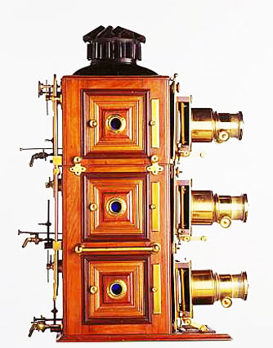
Some were much simpler than this but they were all truly amazing in their time. They were invented in the 1660’s and at first they were lit by candle light! Later better quality and intensity of light was achieved but sometimes the methods used were dangerous and could cause fires. The one we used at Englesea Brook was converted so that it could be powered by electricity. Some had a single lens and other more expensive ones had two or even three lenses and three light sources. These were called biunial and triunial magic lanterns.
The Victorians invented the `Zoetrope` these created the illusion of a moving picture and some of you will have used one of these on your visit to the museum. You may have seen the Victorian style flick books that were popular in Victorian times.
You can make your own Zoetrope at home there are instructions on the web. If you decide to make one, there are some pictures at the end of this sheet, that you can colour in and use for your own model. However, you may like to design your own picture strips; that would be even more exciting.
You could make a pin hole camera for this you will need a cardboard box, a shoe box would be ideal a piece of tissue paper, a piece of paper that you cannot see through and a big piece of dark coloured material to cover your head, like the old fashioned photographers.
- You cut a large rectangular hole in two facing sides of the box ( use the larger sides for this) and cover one side with tissue or greaseproof paper
- Cover the other side with paper that you cannot see through and make a tiny hole in the centre of this second piece of paper.
- Take the large piece of dark material and fix it to the top and sides of the box so that when you cover you head with it, and look at the tissue side of the box no light can get in.
- Point the pinhole at a source of light, a window is fine, cover your head with the cloth and look at the tissue paper. What do you see? It is a good idea to draw what you see. What do you notice about the image? The same was true of the image through the magic lantern and the slides were put in back to front, so that they showed correctly on the screen or white sheet that was often used as a makeshift screen in Victorian times.
- You could experiment by making another hole in the paper and see what happens to the image.
Remember to look at the Zoetrope strips below. Enjoy.

