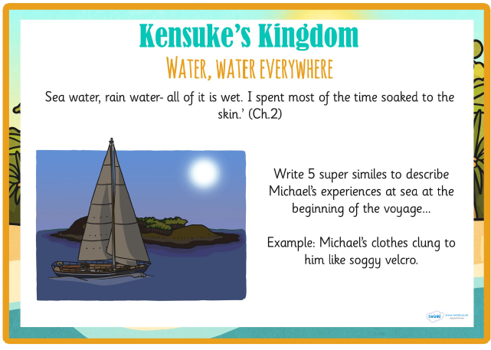
Write some sentences containing figurative language to describe Michael’s experiences at sea during the night that he fell overboard.
Examples
Simile:
Michael’s clothes clung to him like soggy Velcro!

Metaphor:
Studded diamonds sparkled in the ebony sky.

Personification:
Icy monsters swallowed my body as I frantically trod water.

