I know the difference between acute,
obtuse and reflex angles

- A ship is sailing north. The captain wants to go south. How many degrees must he turn the boat? What type of angle is this?

- What is the type of angle of a slice of cake that has been cut into:
  - 4 slices
  - 5 slices
  - 2 slices
  - 10 slices

- Comic Relief was on for 7 hours, from 6pm to 1 am. How many degrees did the hour hand turn during this time? What type of angle is this?

- Draw the following polygons:
  - A triangle with three acute angles
  - A triangle with two acute and one obtuse
  - A quadrilateral with two acute and two obtuse
  - A quadrilateral with one reflex

- Can a triangle contain two obtuse angles? Explain.

- What sort of angles can a quadrilateral have? Describe as many as you can with diagrams.

Answers

- 180˚obtuse
- a) Right angle
b) Acute
c) Obtuse
d) acute
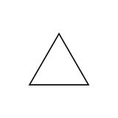
- 210˚ reflex
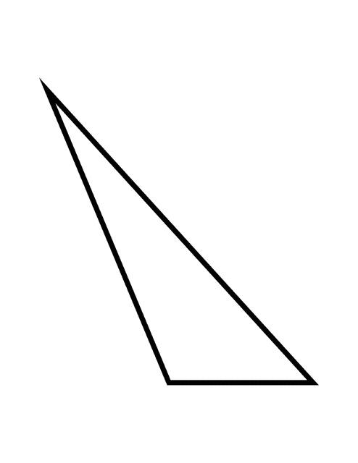
- Answers may vary.
- b) c)

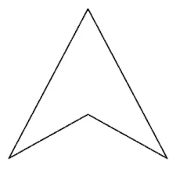
d)

5) No. You would always need a fourth line to connect the
points.

6) 4 right angles = square, oblong
2 acute and 2 obtuse = parallelogram, rhombus, trapezium or
kite
2 right angles, 1 acute, 1 obtuse = trapezium
1 right angle, 2 obtuse, 1 acute = kite
1 reflex, 3 acute = arrowhead
1 right angle, 2 obtuse angles, 1 acute angle = kite
1 right angle, 2 acute angles, 1 reflex angle = arrowhead

