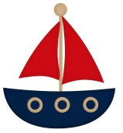
An Adventure at Sea
Your task was to design, build, launch, load and propel a floating vessel.
Name of vessel | Did it float? | Did it propel? | How far did it travel? | Was it able to carry weight?
What worked well? .............................................................................................................................................................................................................................................................................................................................................................................................

If I did this project again, I would improve my vessel by…………………….. ……………………………………………………………………………………………………………………………………………………………………………………………………………………………………………………………………………………………………………………………………………………………………………………………………………………………………………………………………………………………………………………

