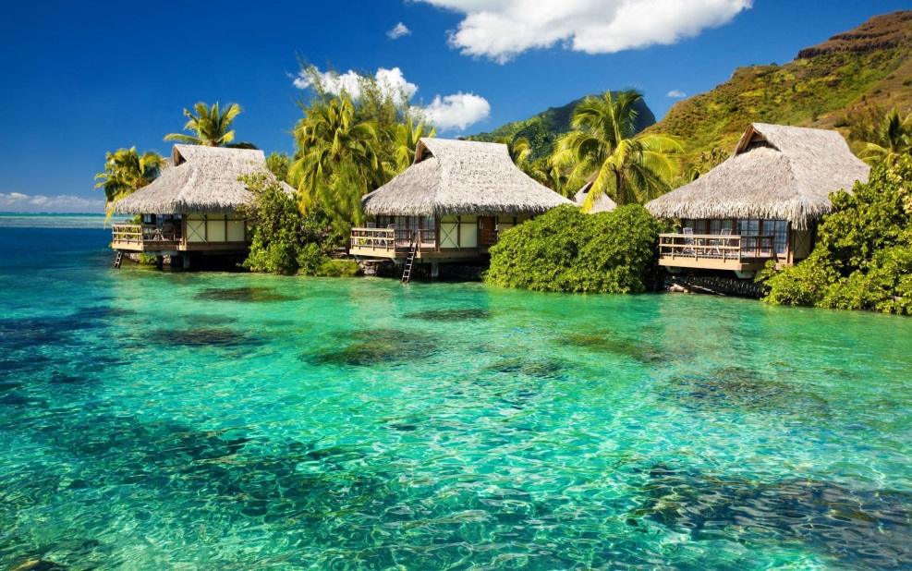
I can begin sentences with imperative verbs

Visit our most exclusive spa and be treated like a star…
Relax on our tranquil beaches where we have brightly coloured sun-umbrellas to protect your soon to be sun-kissed skin.
Go on a wild adventure with our jungle safari experts.
Venture through our plentiful and fully protected rainforest.
Gaze upon animals you could only dream of meeting up close and personal.
Hold one of our baby orang-utans at the wildlife sanctuary.

Have a go at writing your own sentences which begin with imperative verb openers.

