Katsushika Hokusai
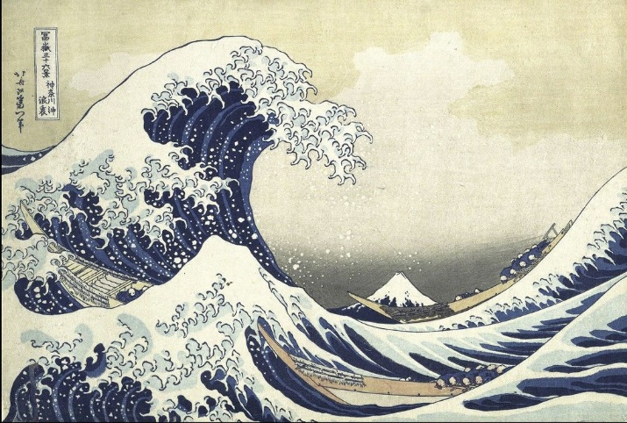
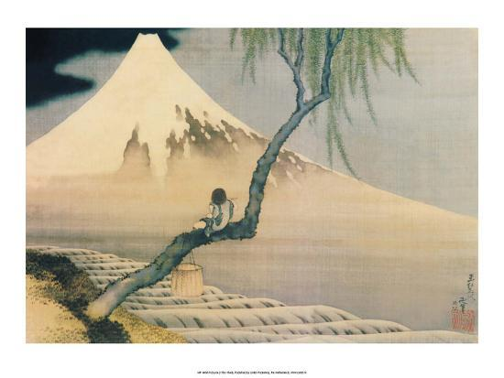

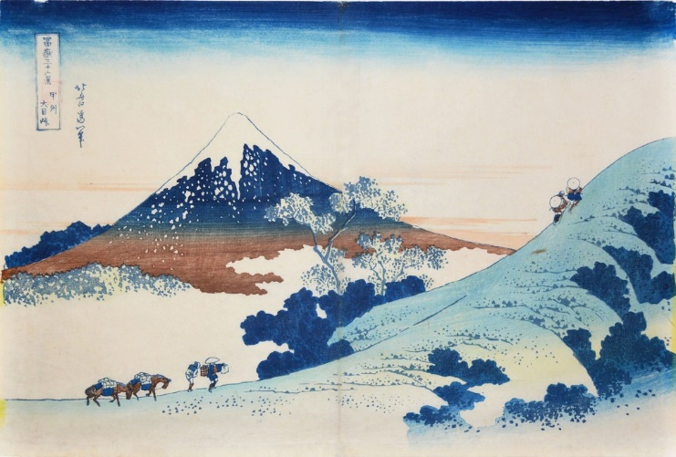
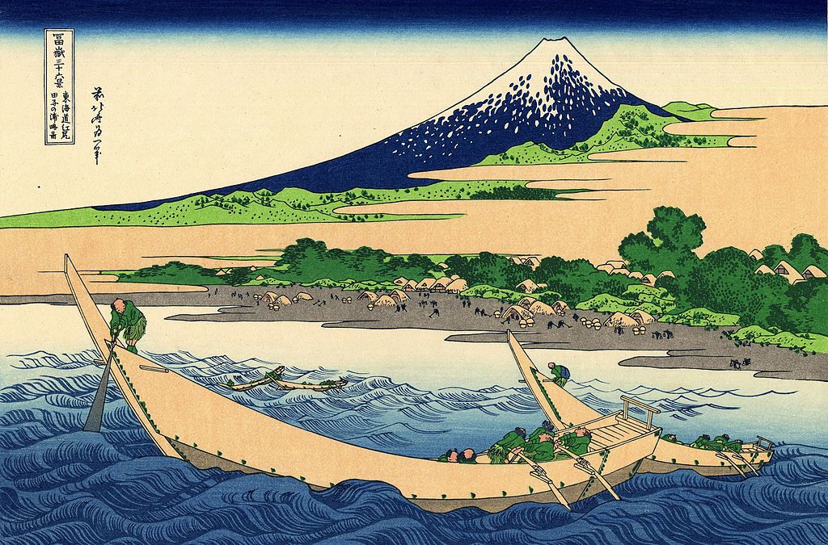
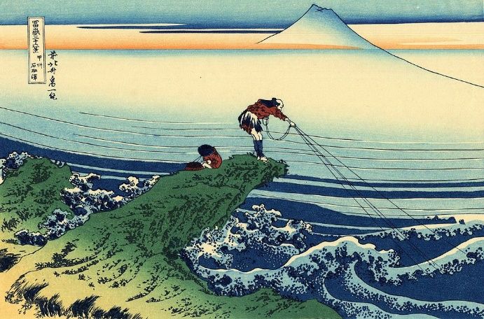
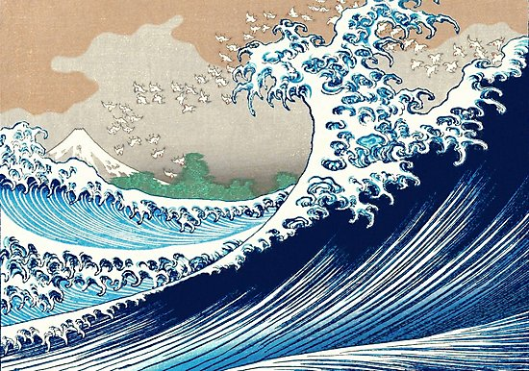

Hokusai was born around October 1760 and died on 10th May 1849. He was a Japanese artist, ukiyo-e painter and printmaker of the Edo period. He created 36 views of Mount Fuji due to a personal obsession with the volcano. His most famous painting was The Great Wave of Kanagawa which was the inspiration of the front cover of Kensuke’s Kingdom.

