I can add brackets, dashes and commas to indicate parenthesis
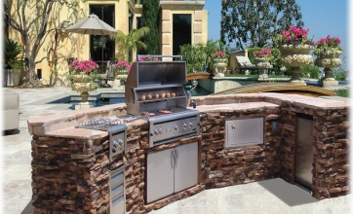
Our chefs, who are all trained to the highest standard, will prepare food at your request.
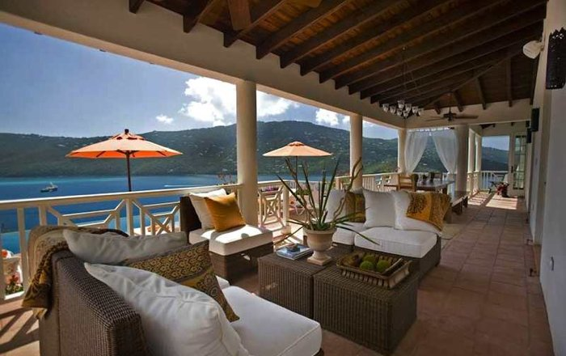
Our island provides a variety of exclusive accommodation types -to suit different budgets and to cater for your every need!

Book before the 28th May and receive 20% off a stay in one of our luxury villas (all-inclusive for a seven-night stay) for only £1700.
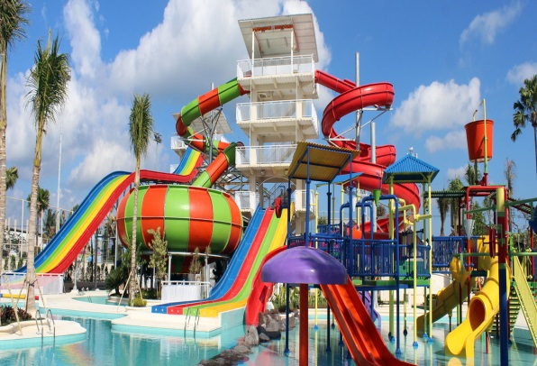
Ride on our awesome waterslides (not for the faint-hearted) at Kensuke’s Water Kingdom!

Can you write your own sentences, which could be included in your leaflet, that contain brackets, dashes or commas to add parenthesis?

