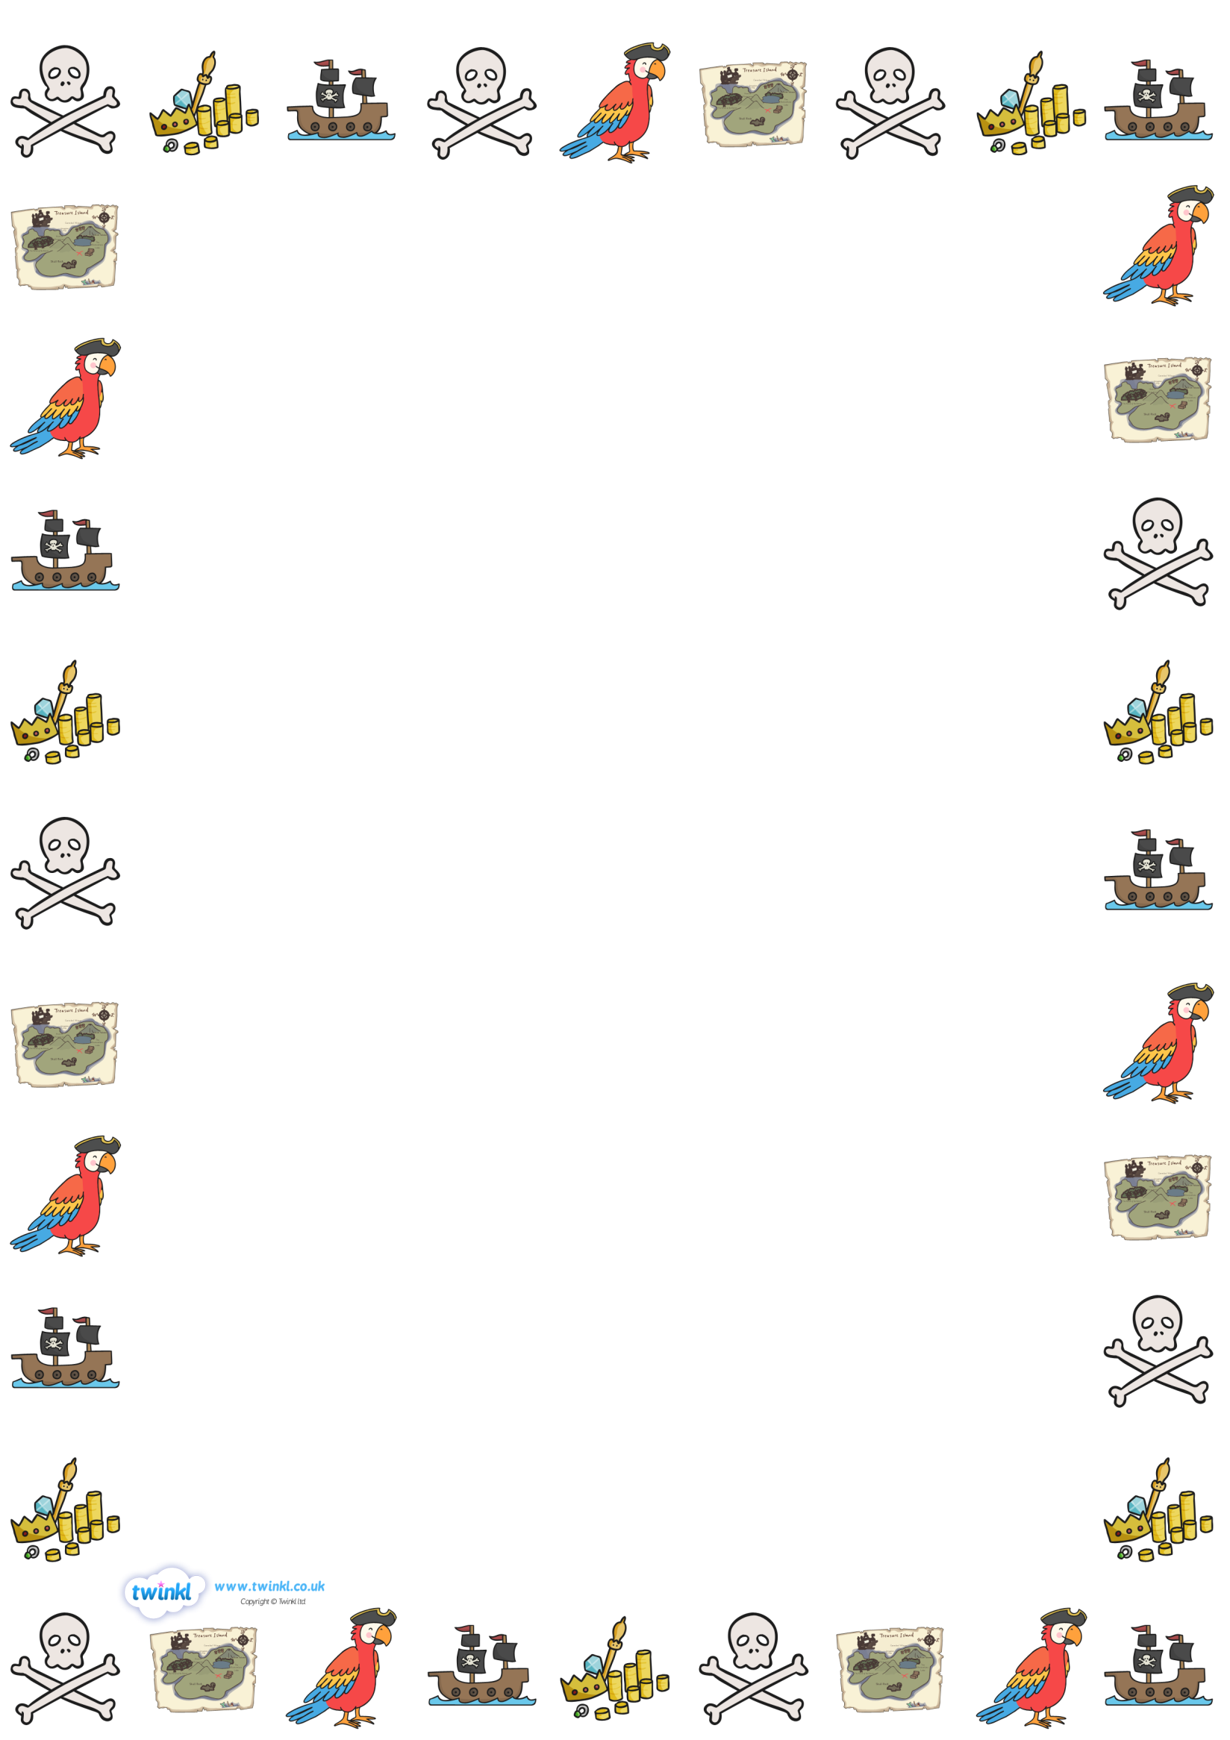
Pirate Code
No snivelling, crying, whinging or spitting.
All treasure to be shared fairly.
All pirates to make sure that their parrots are quiet after lights out.
Swords and guns are only to be used by orders of the Captain or her Master.
Never use your weapons on an unarmed pirate.
Everyone will take a turn in the crows nest and cleaning the decks.
Anyone disobeying an order will walk the plank or may be marooned on a desert island.
----------------------------------------------------------
I agree to the pirate code
Sign below:

TEXT HERE

