Community Past and present
Today we look at some of our museum items, known as artefacts, and see how they link to our community today and times past.
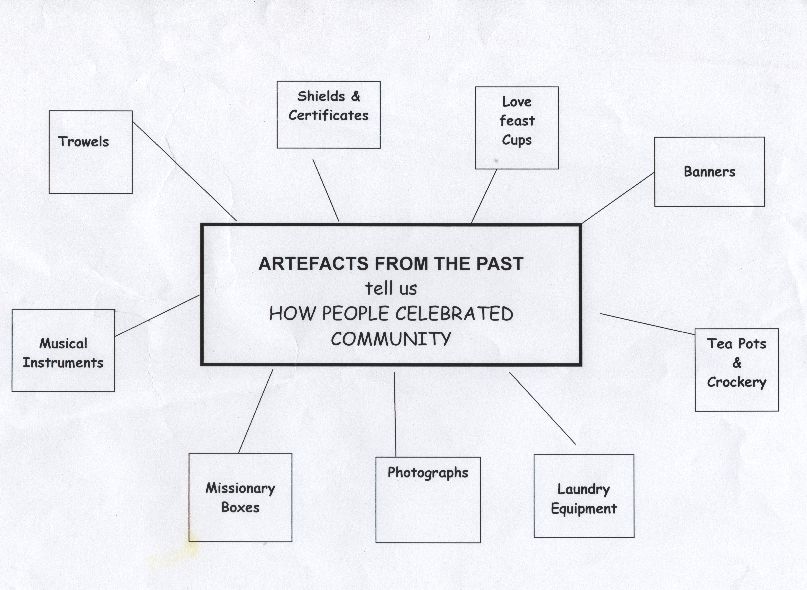
Banners: At Englesea Brook Museum we have Britain’s greatest collection of religious banners. Many are from Sunday Schools, which date back to the 18th century, and for many working class people provided their only means of education.
Others are from churches - Wesleyan Methodist, Primitive Methodist, Free Methodist and the New Methodist Connexion(all now part of the Methodist Church). Many people went to Church three times every Sunday even though it was their only day off in the week.
Other Banners are for the Band of Hope and the Rechabite movement, both of which promoted total abstinence from drinking alcohol, smoking and taking snuff. Children as young as 6 or 7 were encouraged to sign temperance pledge cards promising never to drink alcohol, smoke or take snuff. Indeed one visitor told us her mother signed a temperance pledge on her behalf before she was born! At the museum, we have displayed a temperance pledge card, where the person signing had crossed out `smoking`. How very honest of him.
Organisations like the Band of Hope were popular because they provided other forms of entertainment and different drinks from the Pubs, such as hot chocolate, and they promoted self-improvement.
Tea Pots and crockery: Restaurants were very expensive and rare all these long times ago but people did enjoy community teas in chapels, churches ad village halls. It was a time when they could enjoy each other’s company and for most it was the only way to eat out. You may like to compare this to earlier times this year and then to the present days, during Lock down? P.M. postcards show splendid tea parties and they are also reminders of how people dressed then.
Musical Instruments: You had to make your own music in Victorian times as no one had ipads etc. At the chapel we have the very first organ that was used in the Primitive Methodist Church at Silsden in Yorkshire and a special harmonium that has carry handles and it was taken by hand cart to the market place in Tunstall, Stoke-on-Trent every Sunday for services in the open air. We have other musical instruments from as far a field as Africa. We look forward to the days when you will be able to visit again and see them all.
Shields, certificates and illuminated addresses: Awarded for passing scripture examinations, regular attendance and/or special services to the church and community. In our Role Play of the Victorian Sunday School many children and indeed visitors have been awarded certificates for passing the scripture examinations. As many of you will know the original certificates, we present as part of the role play, were awarded to Ellen Hudson in November 1903 and another to William Wainwright in February 1890.
Love Feast Cups: Used in worship for a special service in which church members shared simple food, water in the Loving Cup and discussed their Christian faith.
Trowels: Community items celebrating the laying of foundation stones when chapels were built.
Photographs: Englesea Brook Museum has a large number of portraits of Ministers and people, who were seen to be important in the various churches and chapels. They can be seen at the museum but also in special books of the time. You may like to see some of them on our website myprimitivemethodists.org.uk
Missionary Collection Boxes: These came in many shapes and sizes and children in Sunday school put a penny in the Missionary box each week to help to pay to send Missionaries to Africa to tell them about God.
Simplified version for younger children.

Banners: Many are from Sunday Schools, which for many working class people provided their only means of education; learning about God and what was known as the 3R’s, reading, writing and arithmetic.
Many people went to Church three times every Sunday even though it was their only day off in the week.
People, including children as young as 6 or 7, signed Pledge cards promising not to drink alcohol, smoke or take snuff. What do you think of this?
Organisations like the Band of Hope were popular because they provided other forms of entertainment and different drinks from the Pubs, such as hot chocolate, and they promoted self-improvement.
Tea Pots and crockery: Restaurants were very expensive and rare all these long times ago but people did enjoy community teas in chapels, churches and village halls. People met with their neighbours and enjoyed each other’s company and for most it was the only way to eat out. Compare this to the situation earlier this year and then to the days of Lock down today! At the museum, we have some post cards that show splendid tea parties during the Primitive Methodist times. These are also good to look at because they show how people dressed in those days so long ago.
Musical Instruments: You had to make your own music in Victorian times as no one had ipads etc. At the chapel we have the very first organ that was used in the Primitive Methodist Church at Silsden in Yorkshire and a special harmonium that has carry handles and it was taken by hand cart to the market place in Tunstall, Stoke-on-Trent every Sunday for services in the open air. We have other musical instruments – see how many you can count when you are able to visit the museum with your parents or school when it is safe to do do.
Shields, certificates and illuminated addresses: Awarded for passing scripture examinations and attending Sunday School every week. As some of you know, in our Role Play of the Victorian Sunday School many children have been awarded certificates during the lesson. Indeed, one may have been, presented to you if your Victorian name, in the lesson, was Ellen or William. The genuine old certificates were awarded to Ellen Hudson in November 1903 and another to William Wainwright in February 1890.
Love Feast Cups: Used in worship for a special service in which church members shared simple food and discussed their Christian faith.
Laundry equipment: Dolly tubs, Dolly pegs, Possers etc. were often used in wash houses, that were shared between a few houses, they also shared the yard and toilets as we saw in a previous work sheet for the schools. Some of our readers may well remember this.
Trowels: Community items celebrating the laying of foundation stones when chapels were built. These looked like cake slices and were silver and ornamental – not actually used.
Photographs: Englesea Brook Museum has a large number of portraits of Ministers and people, who were seen to be important in the various churches and chapels. They can be seen at the museum but also in special books of the time. You may like to see some of them on our website myprimitivemethodists.org.uk
Missionary Collection Boxes: These came in many shapes and sizes and children in Sunday school put a penny in the Missionary box each week to help to pay to send Missionaries to Africa to tell them about God. If you hve been to the museum, you will have put a Victorian penny in the missionary box,whilst singing the worship song `Hear the Pennies Dropping`.

You may like to do a list or a word map of things you have at home or school that tell a community or family story. It may have such items as, an Open day, Sports day or Prize presentation dy at school or perhaps a Wedding, a Birthday or holiday photographs that are special to you.

Enjoy. Have Fun Learning.

