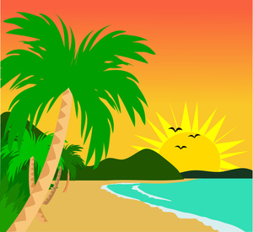
Describing Tropical Paradise Island
The most beautiful, natural and calm island in the world! Relax on our calm beaches where we have brightly coloured sun-umbrellas to protect your soon to be sun-kissed skin. Visit our most exclusive spa and be treated like a star. Go on, you know you want to…
And if all this relaxation is too boring for you, go on a wild adventure through the jungle journey rainforest. Venture through our plentiful and fully protected rainforest. Gaze upon animals you could only dream of meeting up close and personal. This is for all ages so make sure you bring your family along to see the animals up close.
If this isn’t adventurous enough for you, you could take a trip to our survival jungle, filled with trained animals and other people who come to play paintball there alongside you. You must be stealthy and fast! Agility is everything! Get hit by a paintball and you are out. Are you brave enough to face the jungle?
After a long adventure-filled day, you can choose from our vast variety of colourful or peaceful – which ever you prefer – rooms in our Hawaii hotel, south of the island. Everything there is designed to your liking and will be the perfect place for you to stay in after your long day or if you are in a peaceful mood, you can visit our wildlife sanctuaries after you have spent a relaxed morning at the hotel spa. Come visit our island website to book tickets to come visit Tropical Paradise Island. So come down to Tropical Paradise Island and prepare to have the most phenomenal adventure of your life. We’re looking forward to seeing you here. Come here to your island and let the adventure begin.
https://www.google.co.uk/url?sa=t&rct=j&q=&esrc=s&source=web&cd=1&cad=rja&uact=8&ved=0ahUKEwjq5LWQxcjUAhVIb1AKHQLdBIwQtwIIJDAA&url=https%3A%2F%2Fwww.youtube.com%2Fwatch%3Fv%3Dx8JPM_VlzMQ&usg=AFQjCNFsTcwsPn4kNaqZA195Vh4MRyi8Yg&sig2=n0c-annAtHfJpLvw6GRWjw

