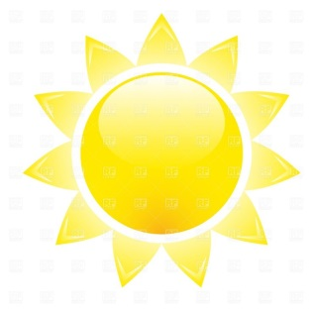
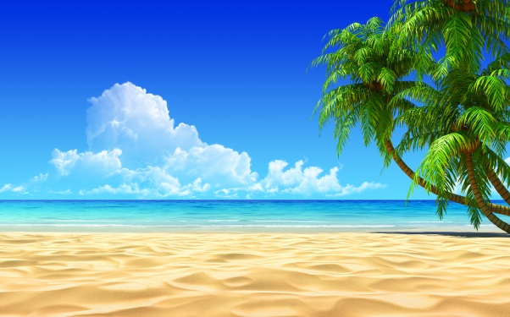
Our Island
Are you feeling tired? Exhausted? Bored of the same routine? Why not take a break at our Paradise Island Resort… Located just off the coast of Fiji, it boasts beautiful greenery which spreads throughout the lush forest and trails of the island. Bathe in the glorious sunshine and enjoy the sound of gentle waves hitting the golden shore or relax around the magnificent infinity pool that stretches out towards the crystal-clear waters of the Pacific Ocean and aqua-blue sky. Stand high on our cliff-tops and admire marvellous panoramic views of our beautiful coral reefs. Our destination is simply perfection!

What are you waiting for? Book now for the holiday of a lifetime…
Accommodation
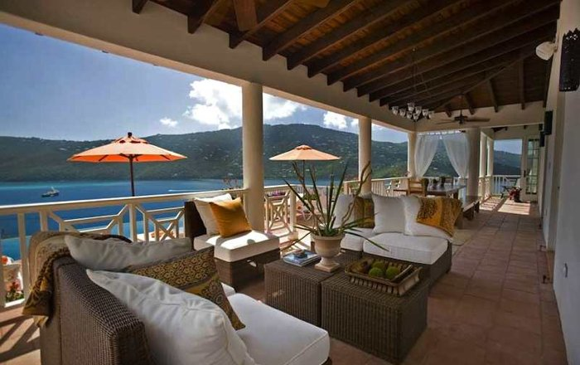
Our island provides a variety of exclusive accommodation types to suit different budgets and to cater for your every need! Check out our phenomenal prices below!
- Beach Huts - £850/week
- Chalets - £300/week
- Self-catering apartments - £550/week
- Themed rooms - £600/week

Or, if you’re after something truly special, why not indulge yourself and book one of our private villas. Perched on the rocky cliff-side, our intimate five-star estate overlooks the idyllic bay. Cliff-edge hot tubs, sweeping sundecks, swinging hammocks and floor-to-ceiling windows decorate these picturesque villas. Shimmering infinity pools invite you to come and cool down from the hot sun. Our tempting terraces give you the chance to experience a magnificent sunset right before your very eyes. Ask your own private chef to rustle up an organic feast from the comfort of your room. Mouth-watering five-star food is only a taste away! How could you refuse?

Book before the 28th May and receive 20% off a stay in one of our luxury villas (all-inclusive for a seven-night stay) for only £1700. The waves are only a click or phone call away…

Activities
Here at Paradise Island, we offer more than just your usual family holiday. Whether you crave a rush of adrenaline or prefer to relax amongst the natural beauty of the Polynesian coast, we are sure to have just what you are looking for. Lounge by one of the four glistening pools; challenge a friend to a game of tennis at our on-site courts; head for the sea for jet skiing and other water sports or choose from one of our fantastic activities over-leaf…

Dive into the exhilaration of the sea and get up close and personal with everyone’s favourite animal. Dolphin interaction lets you plunge into the waters and splash around with our playful bottlenose dolphins.

Water skiing and jet skiing enables you to get in touch with your adventurous side and feel an immense delight as you fly across the ocean.

Feed the orang-utans at our incredible custom made sanctuary or go down to the marina and view magnificent turtles roaming their coves.

Spectacular views can be seen once you hire a guide for the day and explore the island first hand, including rock climbing, cliff jumps and bungee jumping.

Are your children looking for a new experience? Well, why not come join in the fun at Blue Waters ‘Slide and Splash’ Water Park.
Thrilling water slides, a relaxing lazy river and a wondrous wave machine will create memories that will last a lifetime for all.

Or why not just relax and sunbathe by one of our many beach bars and spend the day lounging by the pool, with a cocktail in your hand. Sink into blissfulness and enjoy the heat of the sun as the rays soak onto your body.

Facilities
Paradise Island provides guests with a range of different amenities and services. Whether you are visiting for business or leisure purposes, the facilities available are expertly managed, with the help of the experienced and professional team at the hotel.
Enjoy excellent service, a relaxing ambiance and outstanding facilities at one of the most beautiful islands in the world!

Spa

DISCOVER THE TRUE MEANING OF TRANQUILITY WITH A relaxing SPA treatment. Our spa encourages you to leave stress at the door and set forth on a restorative journey. The Paradise Resort offers a premium setting -outdoors under the rainforest canopy - for a heavenly spa morning or afternoon. Achieve balance and purification with one of our many revitalising treatments, restoring the natural energy of your spirit and establishing harmony between mind and body. Choose from one of our delightful treatments below
- Mud bath - £25.50
- body wrap- £22.50
- massage - £15.25
- facial - £15.25

Go on…indulge yourself and book a treatment now! (All at affordable prices!)

CHILDREN’S SERVICES
Here at the Paradise Resort, we pride ourselves on our family-friendly atmosphere, making children feel as welcome as any other distinguished guest. We provide extensive services designed especially for families, such as babysitting upon request, special kids' menus in all restaurants and a children's swimming pool. Other services include:
- Baby cots available upon request
- Babysitting services available upon request
- Children's swimming pool
- Full animation team
- High chairs provided in restaurants
- Menus for children provided in restaurants

