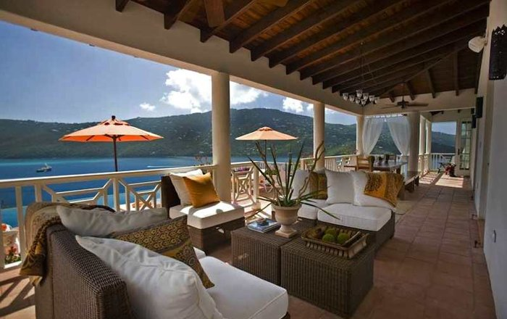
I can use different sentence openers

‘Ed’ word sentence opener
Perched on the rocky cliff-side, our intimate five-star villa overlooks the idyllic bay.
Rated five stars and scattered along our golden sands, stand our resort’s luxurious beach huts.

Noun word sentence opener
Cliff-edge hot tubs, sweeping sundecks, swinging hammocks and floor-to-ceiling windows decorate these picturesque villas.
Kitchens, bathrooms and bedrooms boast natural-chic furnishings, whitewashed walls and include high-tech music sound systems, Apple TVs and laminated floors.

‘Ing’ word sentence opener
Shimmering infinity pools invite you to come and cool down from the hot sun.
Inviting terraces and roof decks give you the chance to experience a magnificent sunset right before your very eyes.

Adjective word sentence opener
Beautiful, serene spas allow you to indulge yourself in a massage or beauty treatment – three treatments free when you book a week’s stay in our all-inclusive hotel.
Mouth-watering five-star food is only a taste away! Just ask your own private chef to rustle up an organic feast from the comfort of your very own villa.

Connectives/Other sentence openers
Additionally, we’ll arrange car rental, chef services, childcare, excursions, spa services and much more.
Moreover, our star team provides a five-star service to meet your every desire.

Imperative Verb sentence opener
Step outside and experience the beach on your very doorstep.
Come and join paradise at Blue Waters Resort now!
Try some of your own sentences for your leaflet, choosing various openers.

