Accommodation
Our island provides a variety of exclusive accommodation types to suit different budgets and to cater for your every need! Check out our phenomenal prices below!
- Beach Huts - £850/week
- Chalets - £300/week
- Self-catering apartments - £550/week
- Themed rooms - £600/week
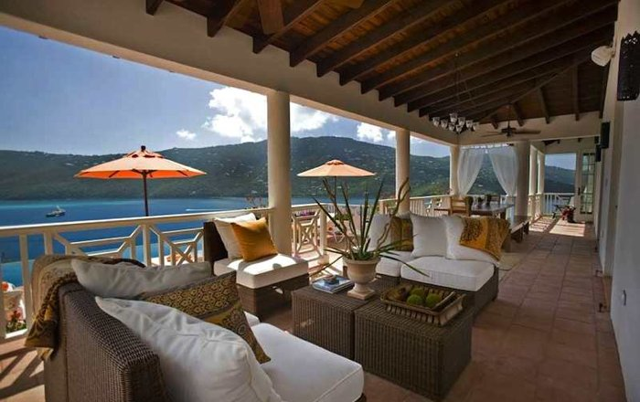
Or, if you’re after something truly special, why not indulge yourself and book one of our private villas. Perched on the rocky cliff-side, our intimate five-star estate overlooks the idyllic bay. Cliff-edge hot tubs, sweeping sundecks, swinging hammocks and floor-to-ceiling windows decorate these picturesque villas. Shimmering infinity pools invite you to come and cool down from the hot sun. Our tempting terraces give you the chance to experience a magnificent sunset right before your very eyes. Ask your own private chef to rustle up an organic feast from the comfort of your room. Mouth-watering five-star food is only a taste away! How could you refuse? The waves are only a click or phone call away…

Book before the 28th May and receive 20% off a stay in one of our luxury villas (all-inclusive for a seven-night stay) for only £1700. The waves are only a click or phone call away…

Success Criteria
Are you adding the following things/techniques to your writing?
You should be!!

1. Sentence Openers
2. Capital letters and full stops
3. Complex sentences
4. Semi-colons, dashes and brackets
5. Rhetorical Questions
6. Persuasive and descriptive language
7. Imperative Verbs
8. Superlative Words
9. A range of punctuation

