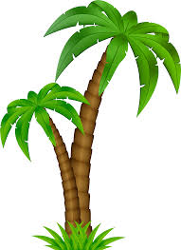
Activities
Here at Paradise Island, we offer more than just your usual family holiday. Whether you crave a rush of adrenaline or prefer to relax amongst the natural beauty of the Polynesian coast, we are sure to have just what you are looking for. Lounge by one of the four glistening pools, challenge a friend to a game of tennis at our on-site courts, head for the sea for jet skiing and other water sports or choose from one of our fantastic activities below…

Dive into the exhilaration of the sea by getting up close and personal with everyone’s favourite animal of the sea. Dolphin interaction lets you plunge into the waters and splash around with our playful bottlenose dolphins.

Water skiing and jet skiing enables you to get in touch with your adventurous side and feel an immense delight as you fly across the ocean.

Feed the orang-utans at our incredible custom made sanctuary or go down to the marina and view magnificent turtles roaming their coves.

Spectacular views can be seen once you hire a guide for the day and explore the island first hand, including rock climbing, cliff jumps and bungee jumping.

Are your children looking for a new experience? Well, why not come join in the fun at Blue Waters ‘Slide and Splash’ Water Park.
Thrilling water slides, a relaxing lazy river and a wondrous wave machine will create memories that will last a lifetime for all.

Or why not just relax and sunbathe by one of our many beach bars and spend the day lounging by the pool, with a cocktail in your hand. Sink into blissfulness and enjoy the heat of the sun as the rays soak onto your body.

