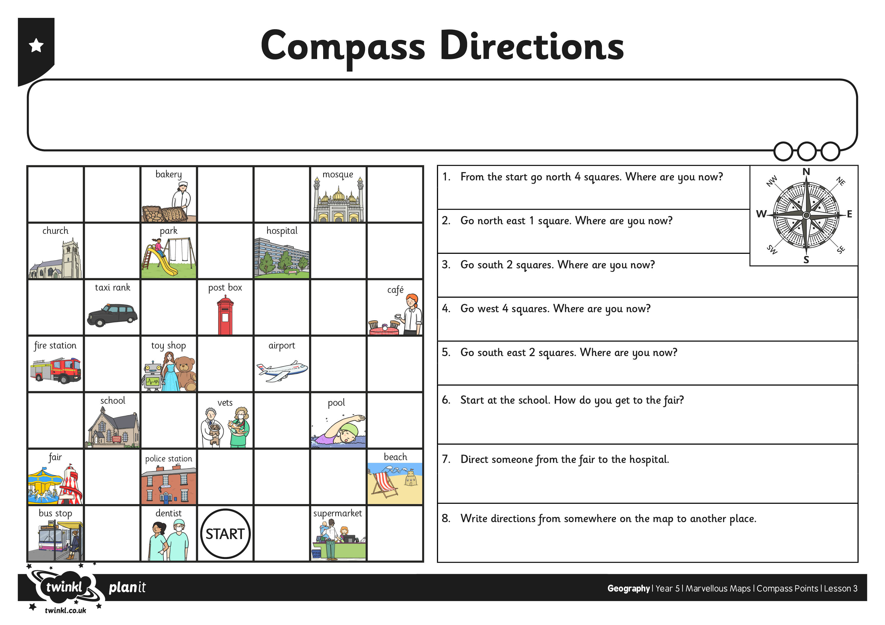
I can use the eight compass points to describe routes on a map.

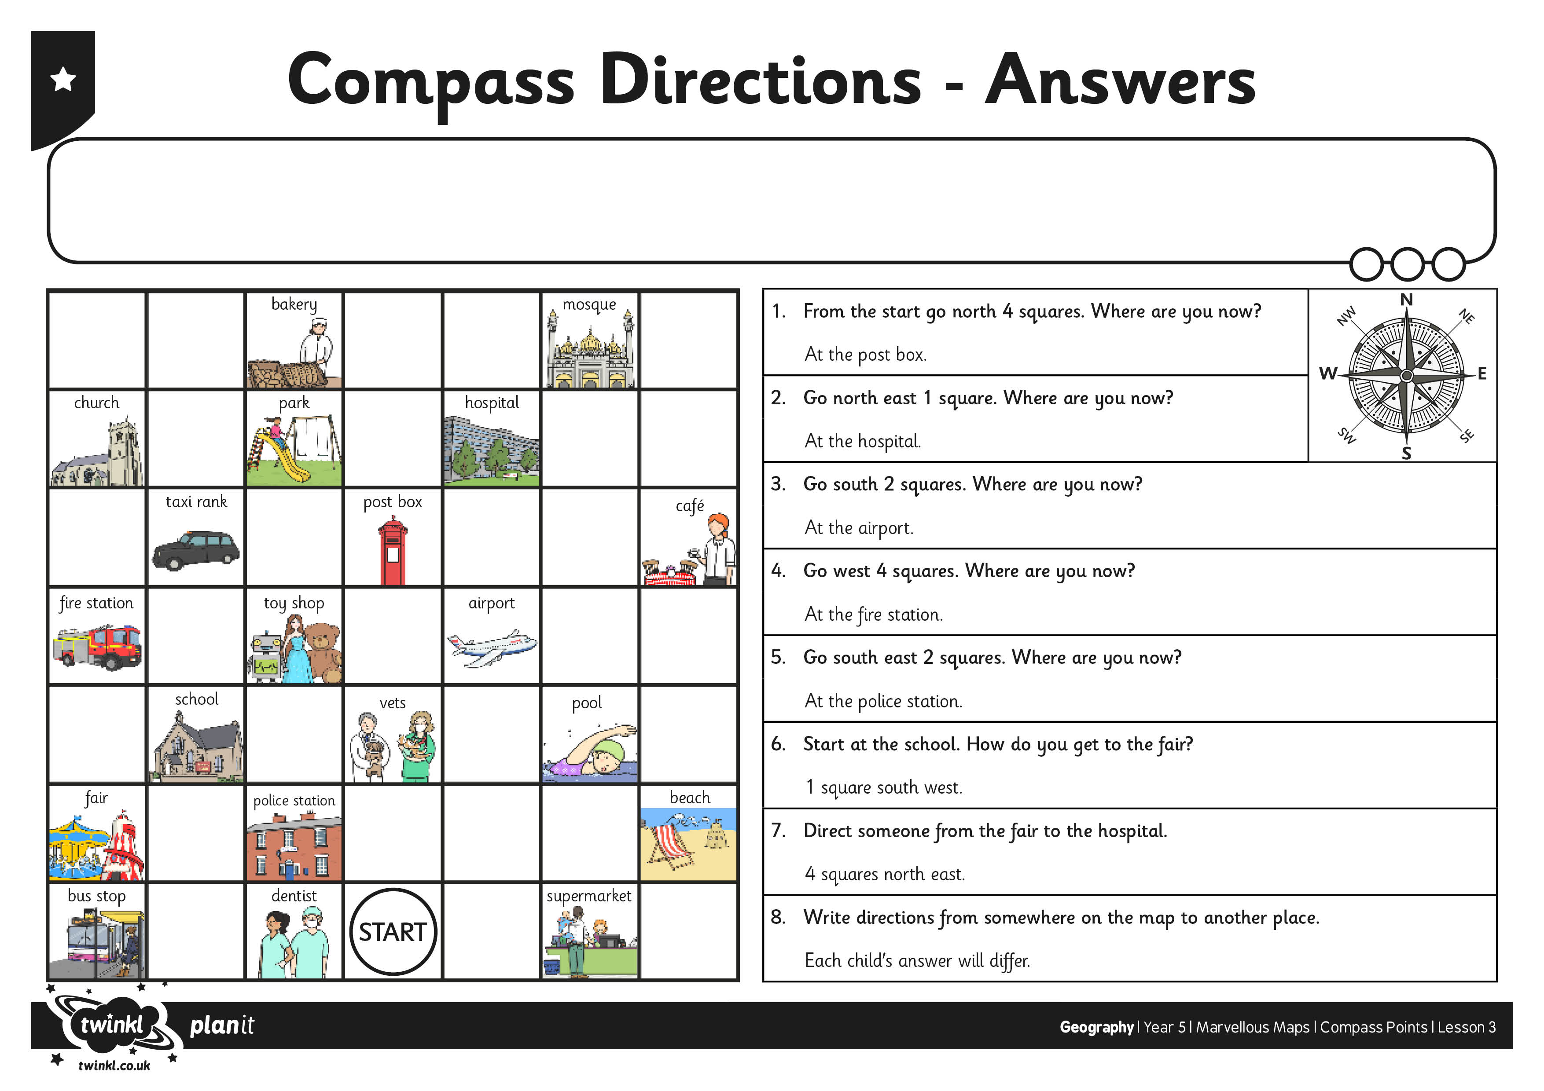
I can use the eight compass points to describe routes on a map.

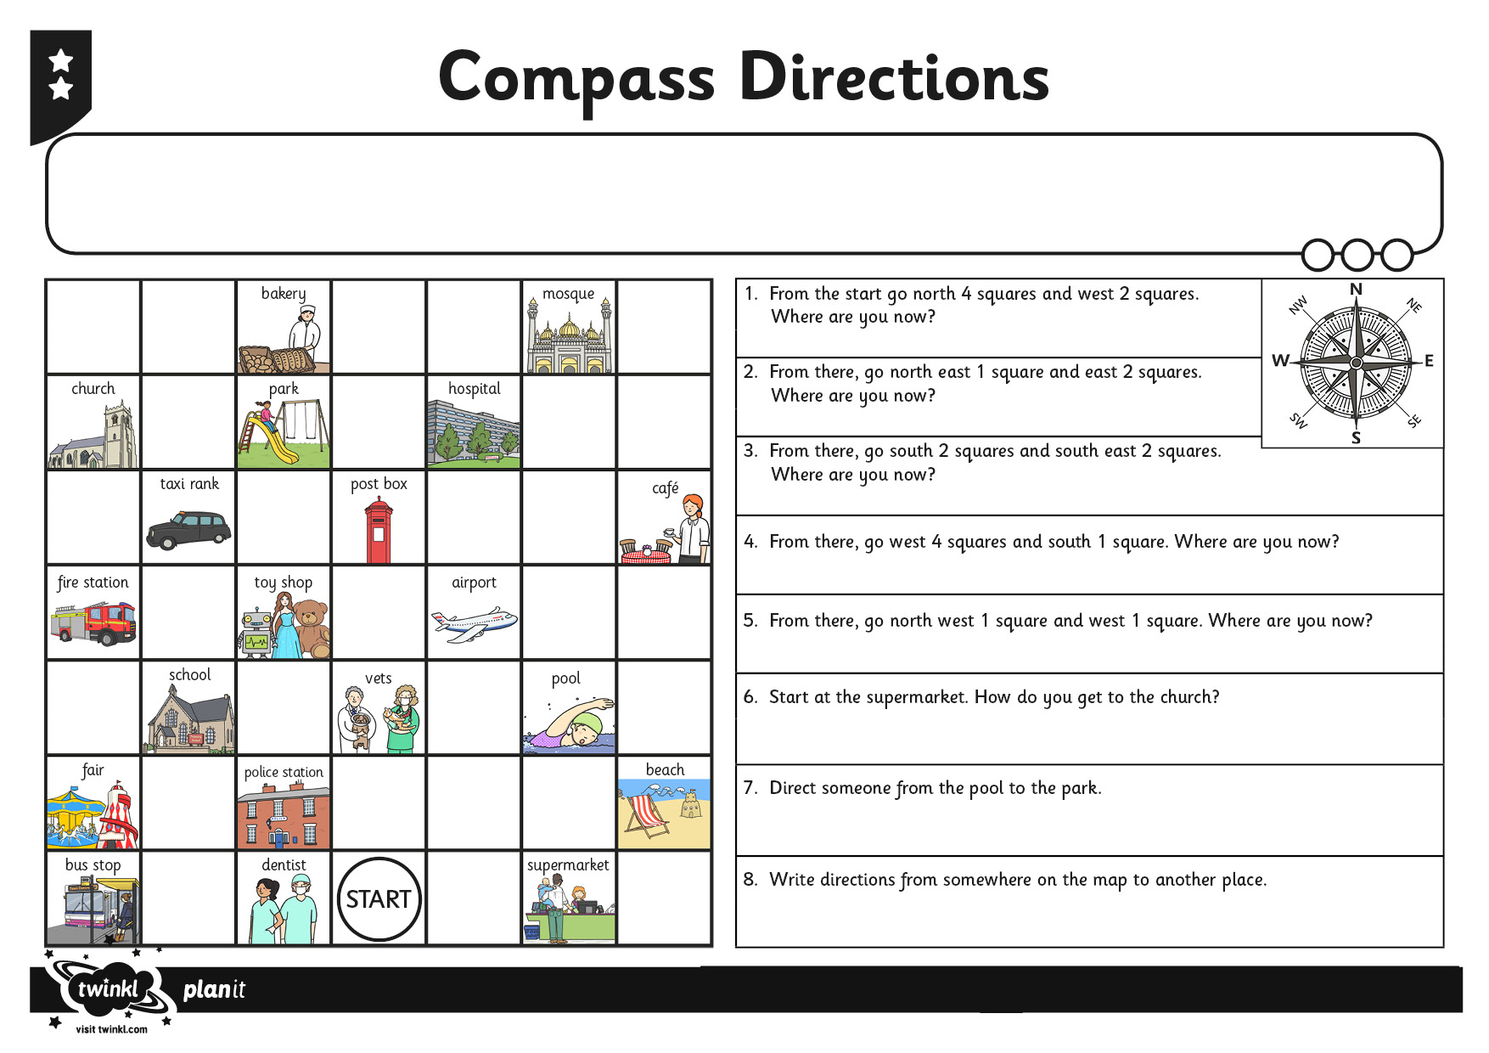
I can use the eight compass points to describe routes on a map.

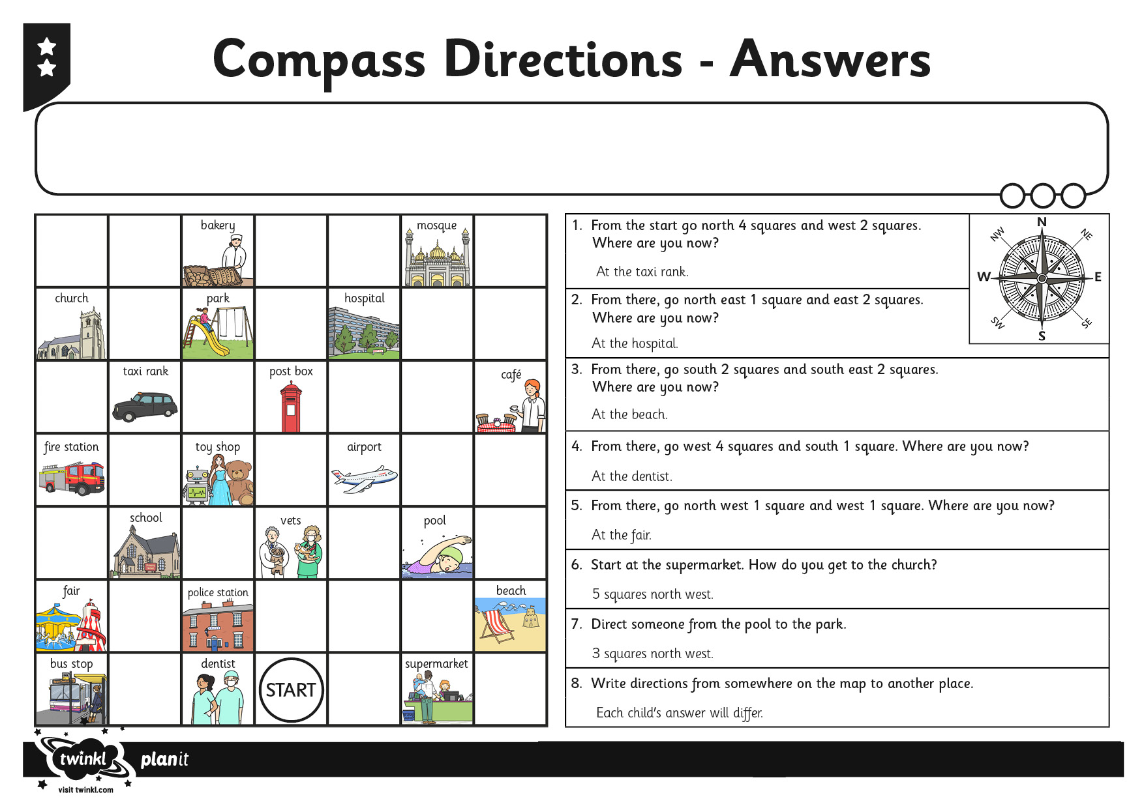
I can use the eight compass points to describe routes on a map.

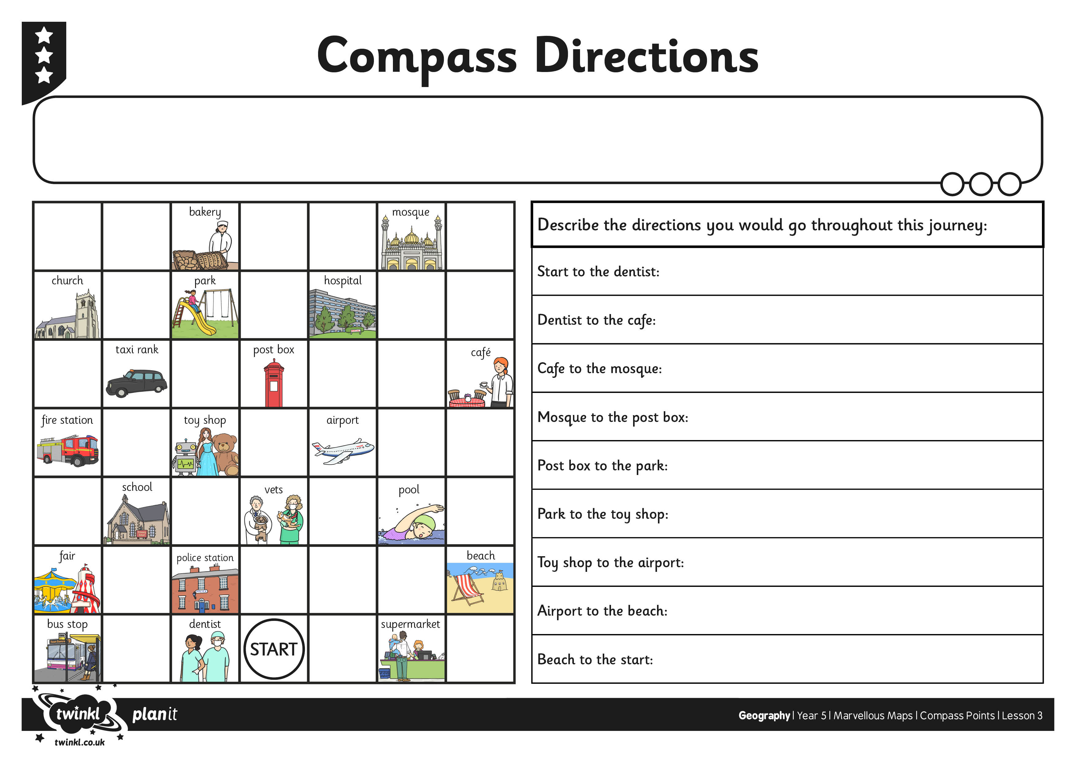
I can use the eight compass points to describe routes on a map.

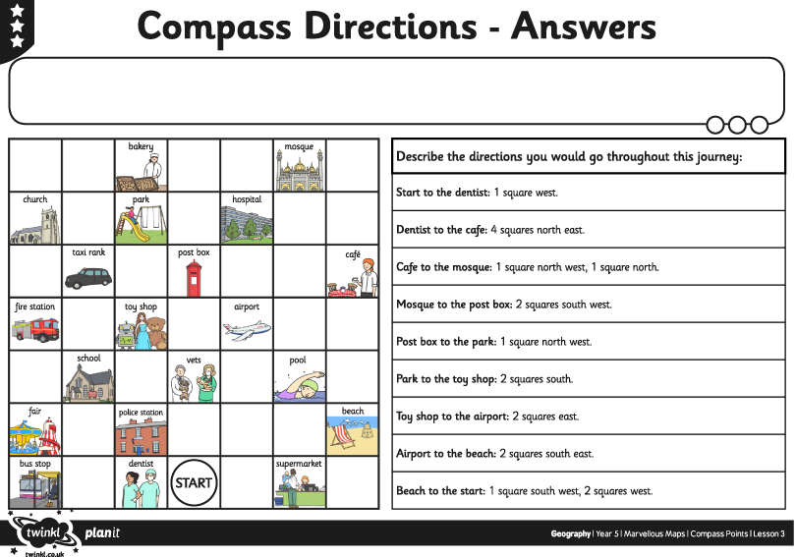
I can use the eight compass points to describe routes on a map.

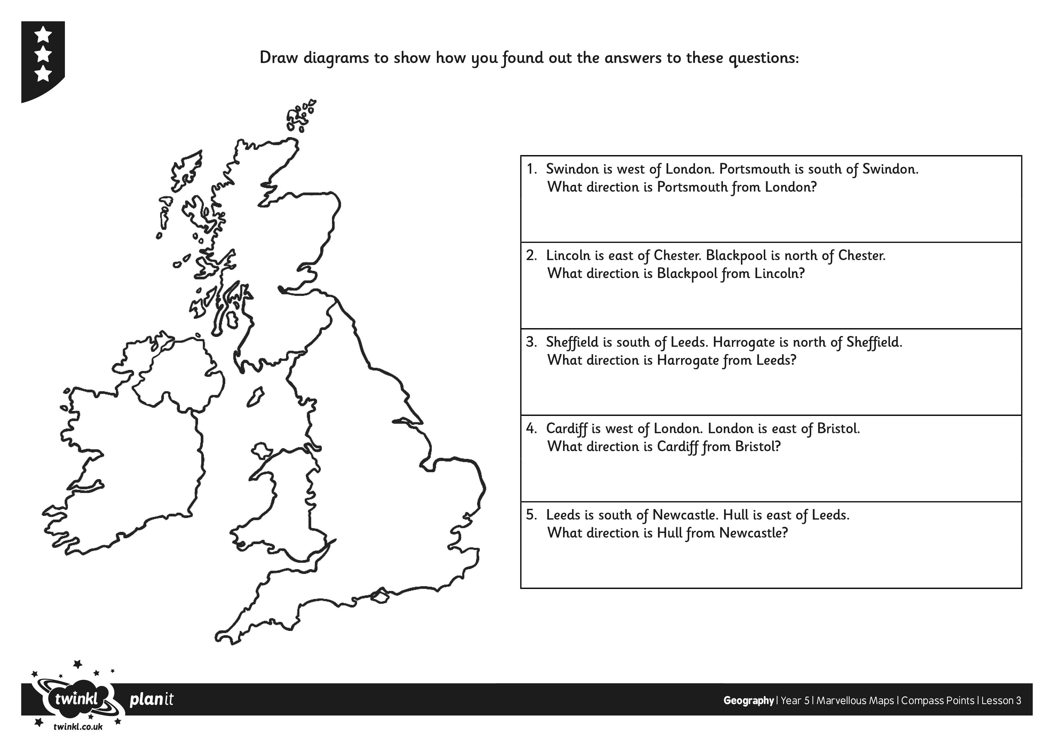
I can use the eight compass points to describe routes on a map.



