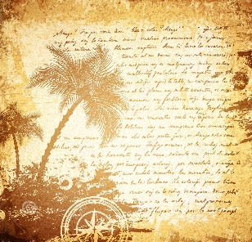  Kensuke’s Kingdom –  Writing a letter to Michiya. | Evidence of features
I have used capital letters and full stops.

I have used capital letters for names of people and places.

I have written in the first person.

I have included complex sentences and relative clauses which are punctuated accurately.
I have used a range of sentence openers.

I have used a range of connectives to begin my sentences.

I have used at least one rhetorical question.

I have included a range of punctuation . , () - ? ! ‘ ;

I have made sure all my paragraphs are indented.

I have included the address and date.

I have included Dear/To…

I have finished my letter with best wishes/with my best wishes…
I have used personal and emotive language to add feeling.

I have included wow words.

I have used a range of conjunctions to connect my sentences.

I have written as though I am Michael speaking to Michiya, Kensuke’s son.
I have used ambitious vocabulary.

