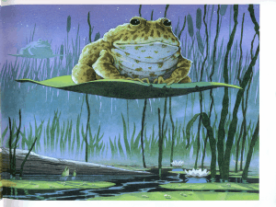
I can write descriptive sentences using
various sentences openers
ly
Loudly, the birds chirped to one another as they settled for the evening.

ing
Glistening water lapped against the silvery rocks on the side of the peaceful lake.

ed
Tired and exhausted, the rotund amphibians settled comfortably upon their lily-pads.

Noun/Adjective
Moonlight cast a silvery glow across the tranquil lake.
Tall reeds swayed gently in the warm evening breeze.

Conjunction
As the sun set that evening, the sky turned into an alluring array of colours

Time connective
Within minutes, moonlight streamed across the tranquil lake, as the tweeting and shrills of the forest birds resonated throughout the woodland and surrounding fields.

Word Bank
Majestically Quietly Silently Nonchalantly Happily Contentedly Ominously Gently Tiredly Proudly Slowly Brightly Softly
Flickering Glimmering Sparkling Shimmering Peering Sitting Glancing Looking Croaking Tweeting Blowing Waving Glistening
Tired Exhausted Settled Perched Nestled
Large Round Green Speckled Tall Slender Thin Ivory White Bright Silver Blue Orange Fluffy Cool Warm Calm Tranquil
While As Although Even though With Until Since When
Within minutes Soon After Just before

