Scene 1: James wakes up at 8am to see that it has snowed heavily overnight.
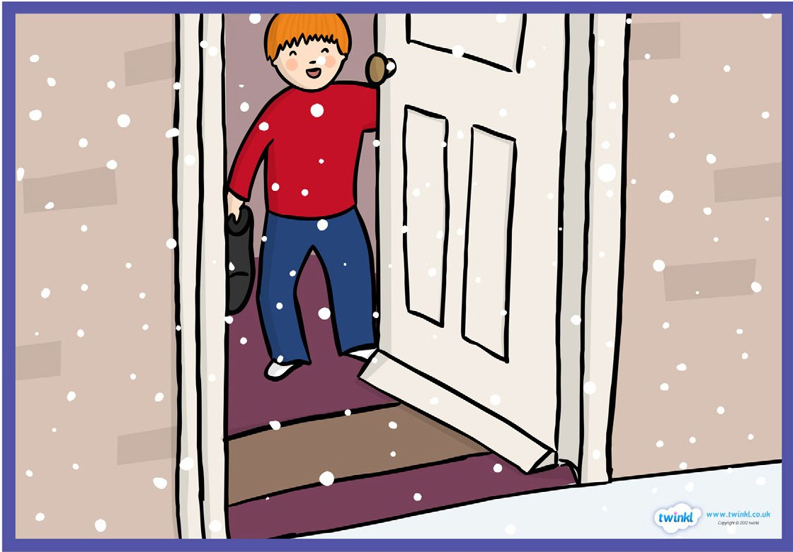

James wakes up at 8am to see that it has snowed heavily overnight. James jumps out of bed and gets dressed ready to play in the snow. He sees his parents as he runs through the house. His mum makes sure he is dressed ready for the cold. James goes outside to play.

Task:
Begin by practicing use of speech, similes, first person writing and sentence starters. Create some relevant sentences using these features that may be used in the final piece.

Write no more than 3 paragraphs describing this scene.
Set the scene. Think about how James felt waking up to snow in the garden. Think about the conversations he may have had with his parents. Describe his feelings. Describe what he sees (in the house, through the window, when he opens the door).

Writing checklist:
- Appropriate sentence starters for each sentence (time connective, adverb, adjective, noun, -ing verb, -ed verb)
- First person (from James’ point of view)
- Speech (“ “)
- Brackets to add extra information
- Semi-colon
- Emotive language
- Descriptive language (including adjectives, similes, metaphors)
- Conjunctions
- Varied punctuation (!, ?, .)

