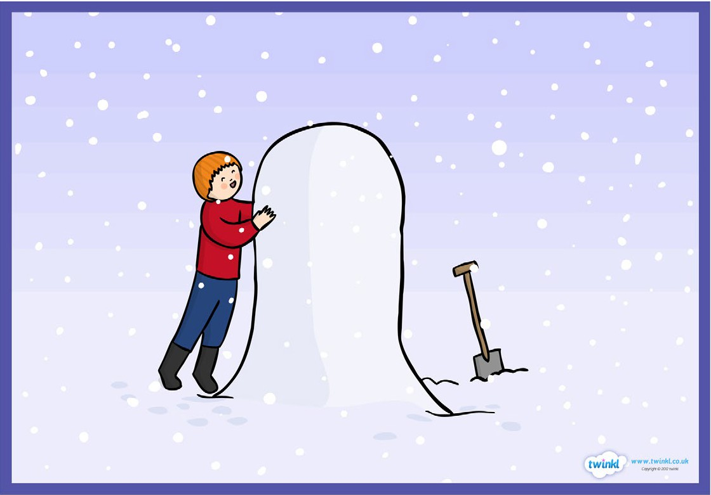
Scene 2: James starts playing in the snow. After a short while he decides to build a lifesize snowman.

James starts playing in the snow. He runs and jumps in the snow. He throws a snowball at the house, his mum looks cross. After a while he decides to build a life size snowman. This takes him a while (we see him have his dinner before carrying on). He collects accessories from the house to finish off his snowman (a hat and scarf, a satsuma for a nose and some coal for the buttons).
Task:
Begin by practicing use of speech, similes, first person writing and sentence starters. Create some relevant sentences using these features that may be used in the final piece.

Write no more than 3 paragraphs describing this scene.
Set the scene.Describe the snow. Describe the scene around James. Think about the contrast between the house and outside (warm / cold). What might James say to his parents about his snowman? Think about how James feels whilst he builds his snowman. How does he decide what accessories to use? How does James feel once the snowman is complete? Describe the snowman.
Writing checklist:
- Appropriate sentence starters for each sentence (time connective, adverb, adjective, noun, -ing verb, -ed verb)
- First person (from James’ point of view)
- Speech (“ “)
- Brackets to add extra information
- Semi-colon
- Emotive language
- Descriptive language (including adjectives, similes, metaphors)
- Conjunctions
- Varied punctuation (!, ?, .)

