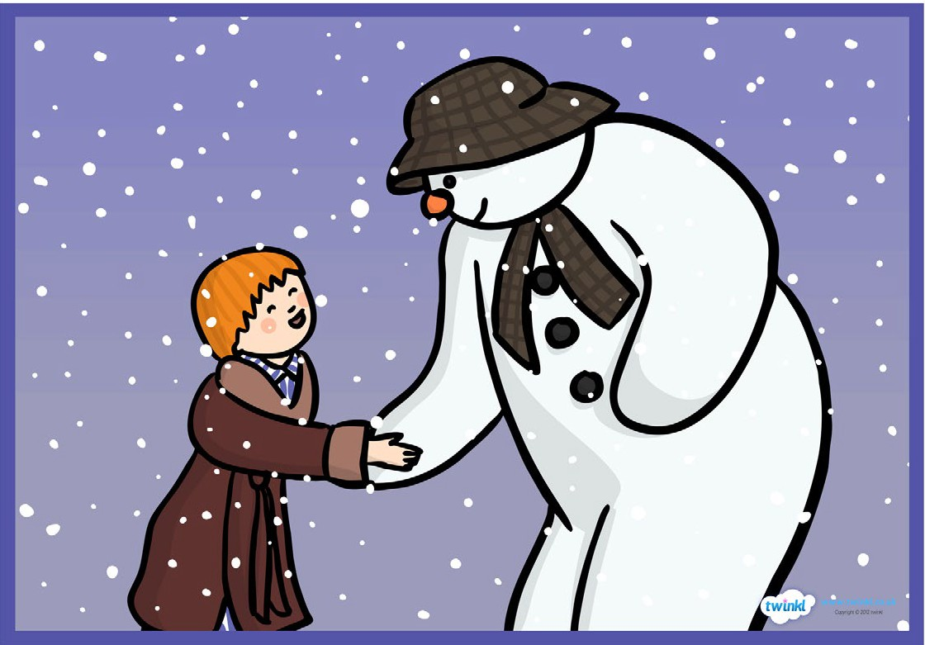
Scene 3: James wakes up at midnight to see that his snowman has come to life.

James wakes up at midnight to see that his snowman has come to life. James and the snowman meet and decide to explore James’ house.

Task:
Begin by practicing use of speech, similes, first person writing and sentence starters. Create some relevant sentences using these features that may be used in the final piece.

Write no more than 3 paragraphs describing this scene.
Think about the time of this scene and describe it (when does the snowman come to life?). Set the scene. Describe the snowman now that he has come to life. What might James say to the snowman? What might the snowman say to James? What do they do around the house? How does the snowman feel?

Writing checklist:
- Appropriate sentence starters for each sentence (time connective, adverb, adjective, noun, -ing verb, -ed verb)
- First person (from James’ point of view)
- Speech (“ “)
- Brackets to add extra information
- Semi-colon
- Emotive language
- Descriptive language (including adjectives, similes, metaphors)
- Conjunctions
- Varied punctuation (!, ?, .)

