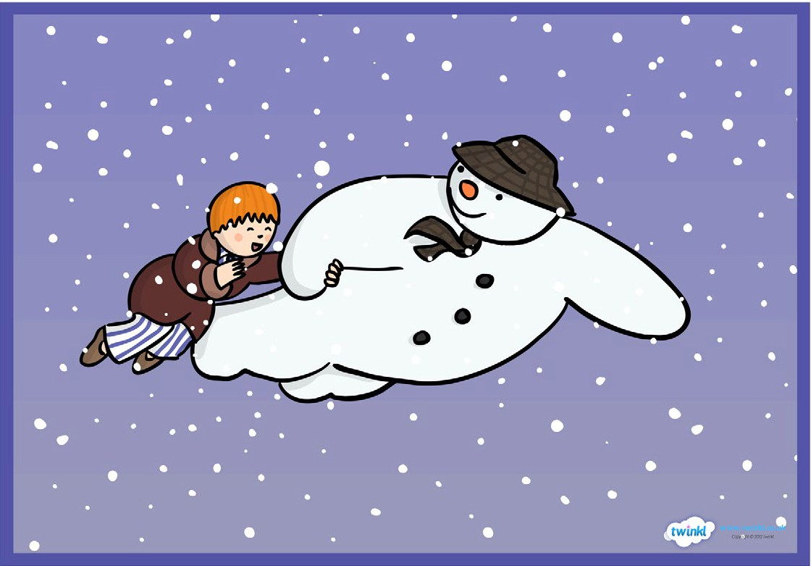
Scene 4: James and the snowman take flight.

James and the snowman take flight. They visit lots of different places. They join a snowmen party. Finally, they meet Father Christmas and his reindeer.

Task:
Begin by practicing use of speech, similes, first person writing and sentence starters. Create some relevant sentences using these features that may be used in the final piece.

Write no more than 3 paragraphs describing this scene.
Set the scene. Think about what James and the snowman might have talked about. Describe the things they saw and did on their journey.

Writing checklist:
- Appropriate sentence starters for each sentence (time connective, adverb, adjective, noun, -ing verb, -ed verb)
- First person (from James’ point of view)
- Speech (“ “)
- Brackets to add extra information
- Semi-colon
- Emotive language
- Descriptive language (including adjectives, similes, metaphors)
- Conjunctions
- Varied punctuation (!, ?, .)

