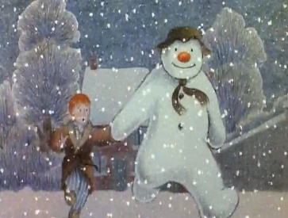
The Snowman (Scene 1)

When I awoke from my peaceful slumber, the room was filled with light and silence. Drawing back the heavy, blue curtains which hung still across my window, I gazed in sheer wonder at the thick layer of fresh snow that had steadily fallen throughout the night. That particular morning had brought the heaviest snow I’d ever seen and I knew then that my day was going to be magical…
As the clock struck 8 am, I quickly dressed and ran down the stairs almost knocking my father over! Quickly, I grabbed the warm toast that had just popped up from the toaster and I spread butter and strawberry jam over its surface. Devouring it with speed, I stared out of the window once again. Filled with excitement, at the prospect of adventures in the snow, I hastily found my thick socks and wellies and headed towards the back door. Eagerly, I clutched the door handle and pulled. Placing a woollen hat firmly on to my head, my mother laughed and shouted, “Have fun my darling.”
“I will,” I promised her, with the biggest smile on my face.
Mesmerised by the wonderland that confronted me, I happily ran to the centre of my back garden. Snowflakes danced and fluttered gently around me as I stared in awe at this new world.

