Fill in the table with your thoughts on the images on the second page.
Use the titles of Jesus and decide which titles reflect which images.
Briefly explain your choice of image and title.
Titles of Jesus:
Son of Man, Son of God, Saviour, Suffering Servant, King, Immanuel, Teacher, Friend of Sinners, Good Shepherd, Christ child.
Image Number | Explanation
1
2
3
4
5
6
7

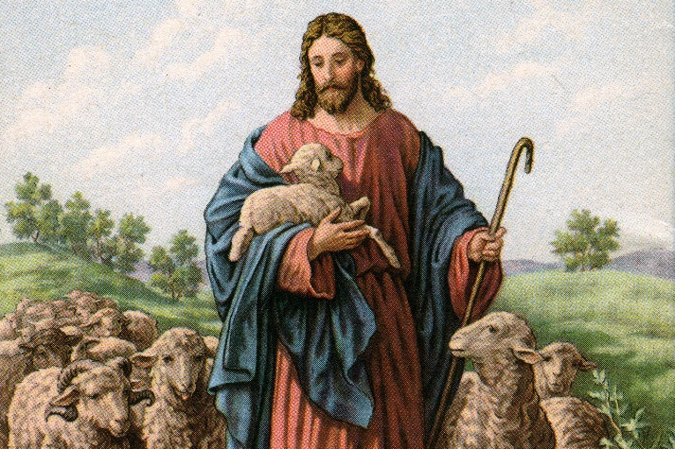
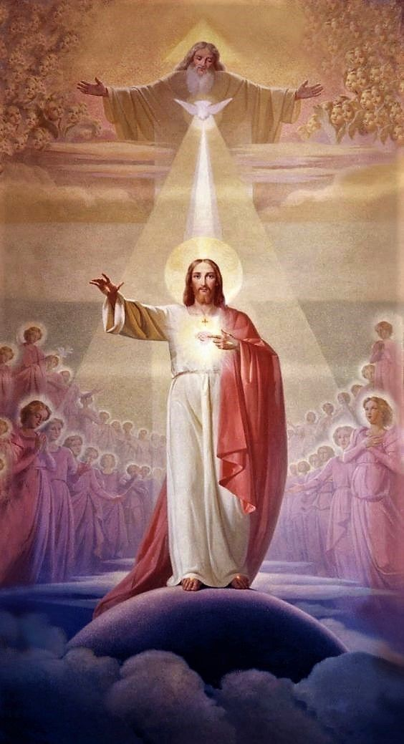
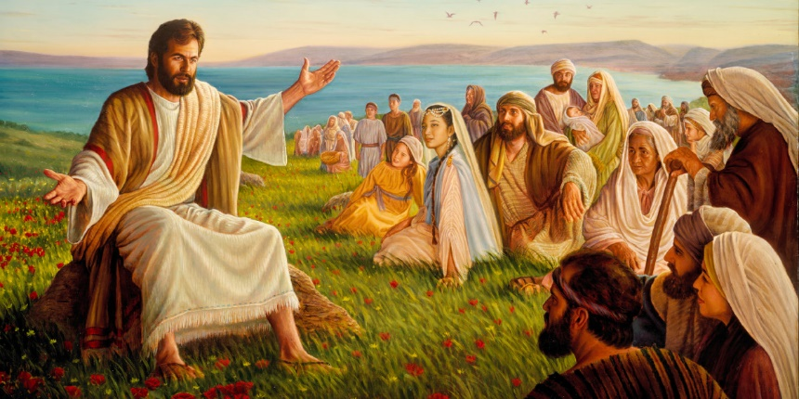
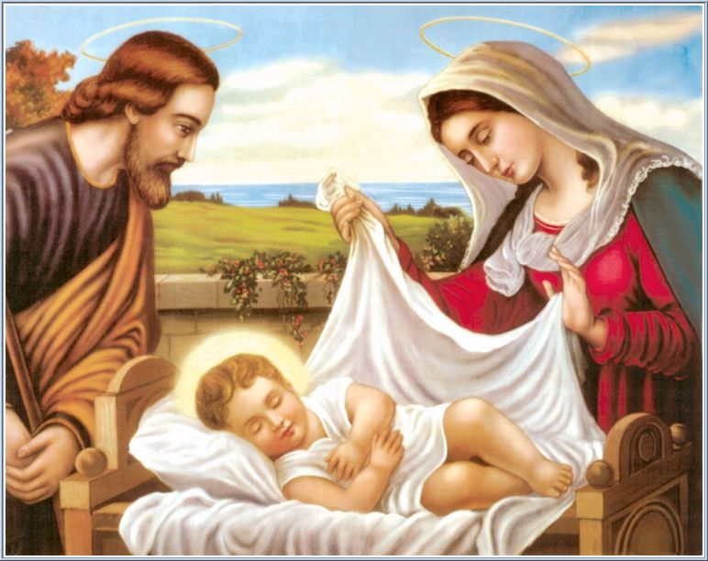
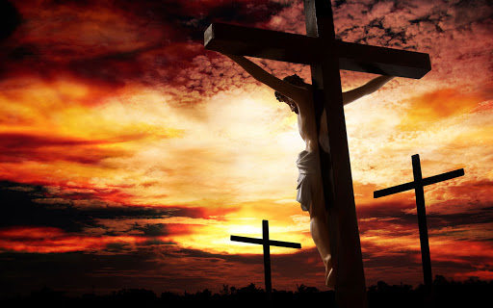
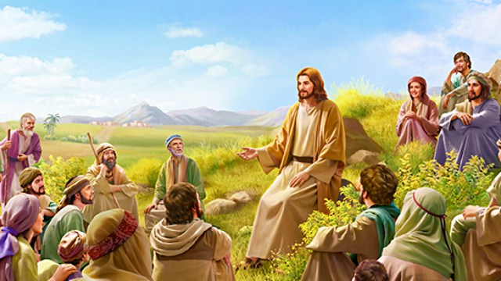
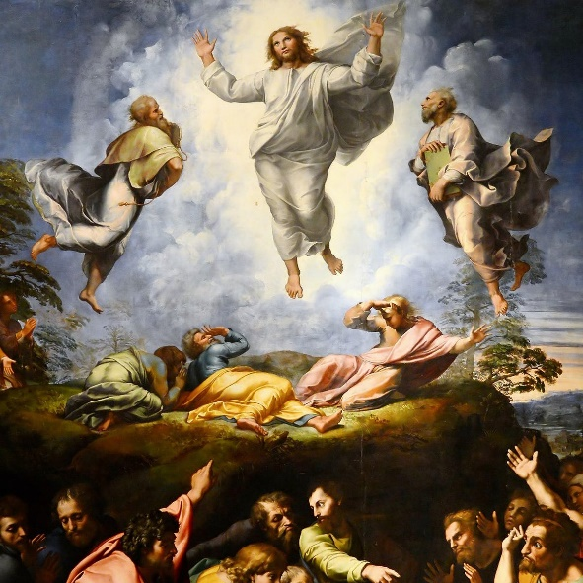
3
7
6
5
4
2
1

