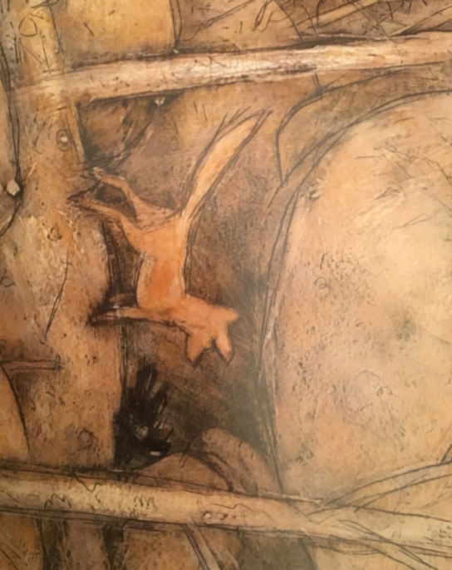  1. | 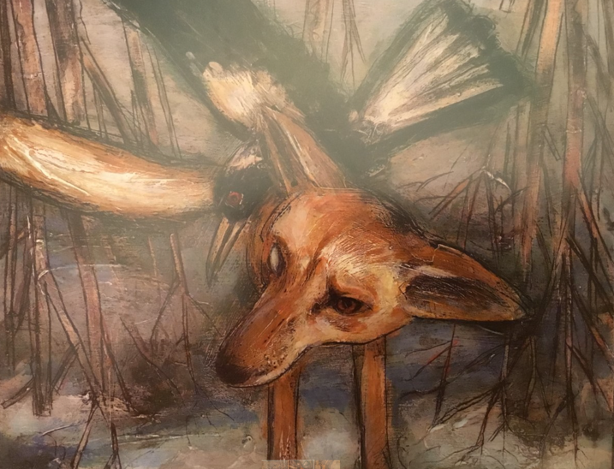  2. | 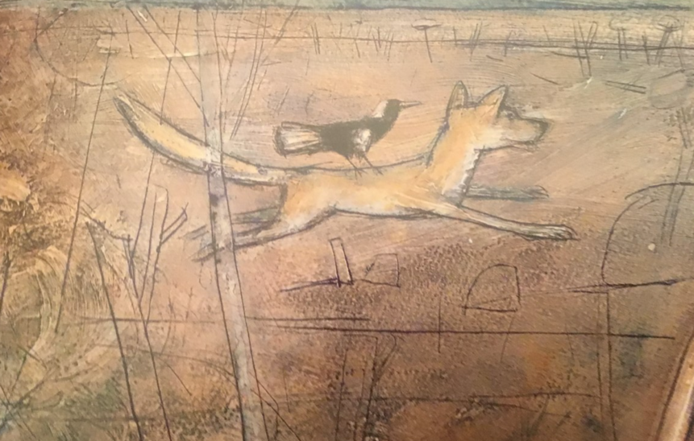  3.
“I will never again be able to fly,” she whispers. | “I see a strange new creature,” she says. | “Fly, Dog, Fly!”

*Choose one of the pictures. What do you think Magpie is saying? Write 5 sentences using speech marks.

**Choose one of the pictures. Choose your character – either Magpie or Dog. What do you think they are saying? Write 5 sentences using speech marks.

***Choose one of the pictures. What do you think Magpie and Dog are saying? Write some sentences to show a conversation between the two characters. Remember to use speech marks.

