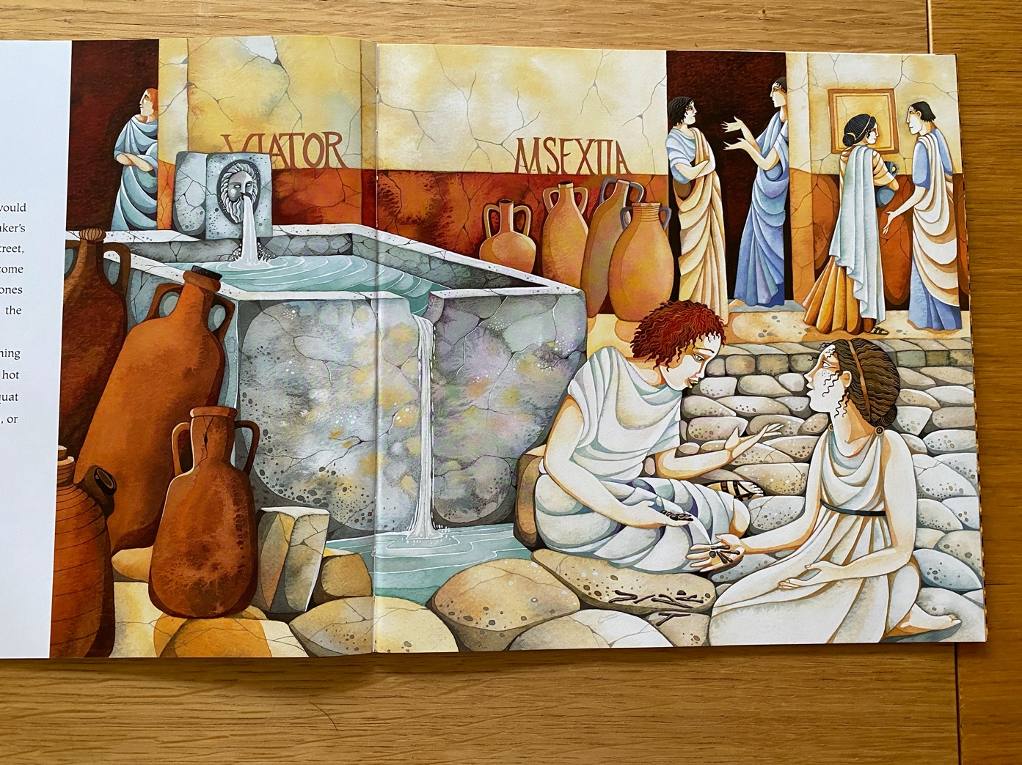* - Using the picture from the book match the prepositional fronted adverbial to the main clause.

1 | Infront of the fountain, | A | four large pots were placed.
2 | In the doorway, | B | two ladies stood chatting.
3 | In the middle of the wall, | C | the water poured out.
4 | At the bottom of the fountain, | D | a lady stood with her arms folded.
5 | Through the stone man’s mouth, | E | a man and woman were talking
6 | Behind the wall, | F | two girls played jacks with old bones.
7 | At the top of the steps, | G | the water crashed onto the rocks below.

