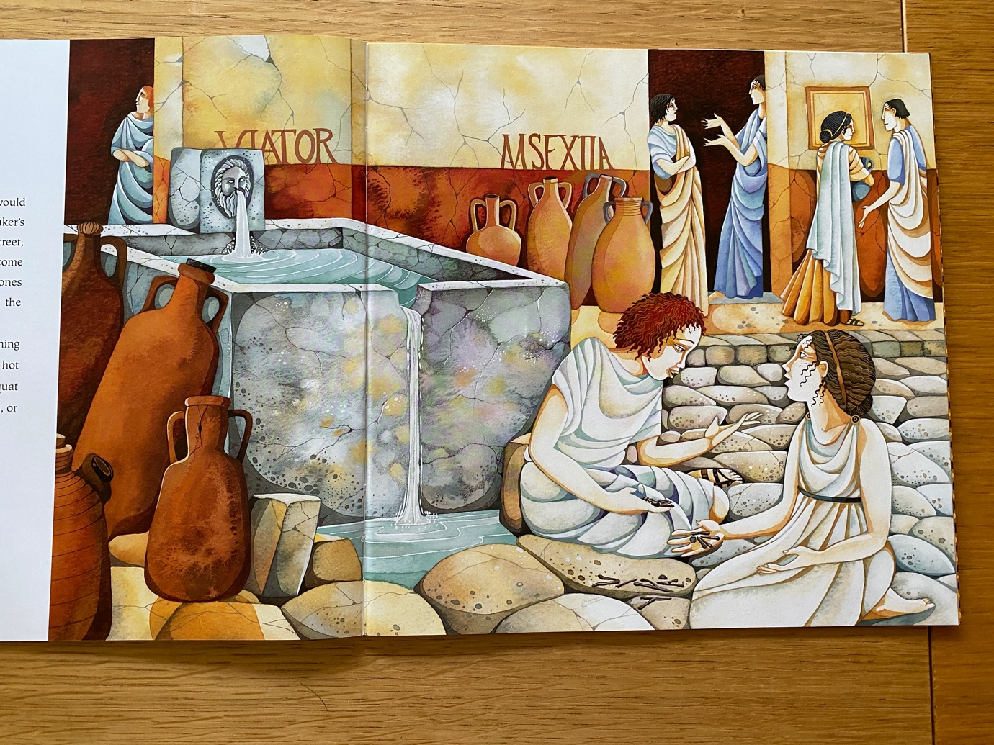** - Using the picture from the book, use the prepositional fronted adverbials below to create a descriptive sentence.

1 | Infront of the fountain,
2 | In the doorway,
3 | In the middle of the wall,
4 | At the bottom of the fountain,
5 | Through the stone man’s mouth,
6 | Behind the wall,
7 | At the top of the steps,

