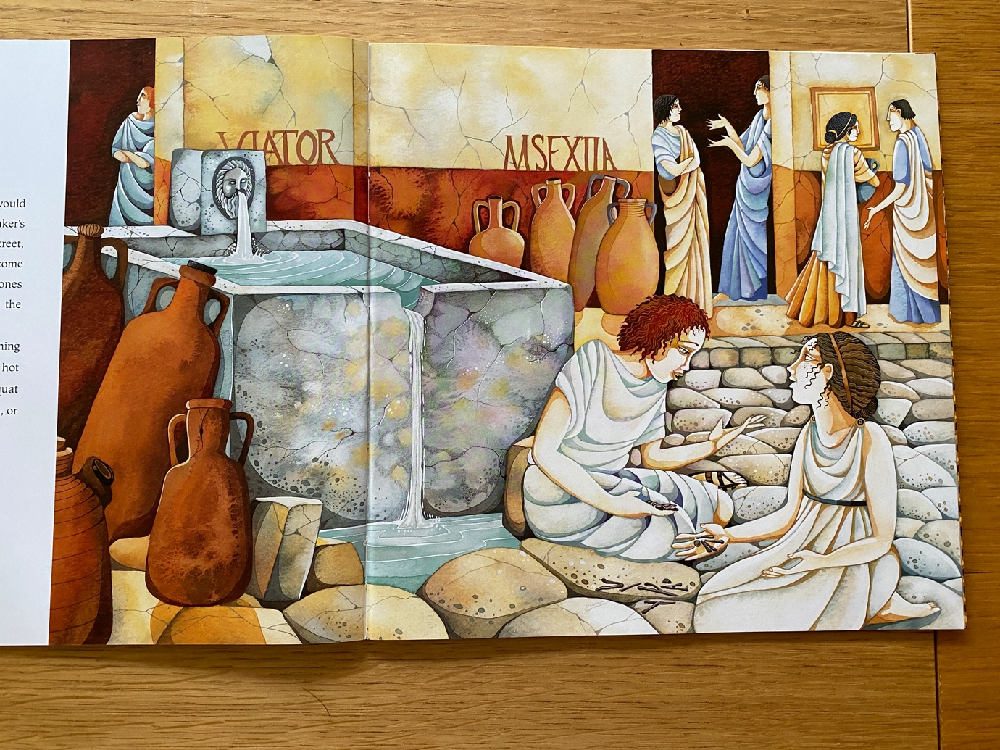
*** - Using the picture from the book, use the bank of prepositions underneath to create seven descriptive sentences with a prepositional fronted adverbial.

Above | Beneath | At the back | Near | At the top of
Beside | Close to | Between | Within | In the middle of
Across | Towards | Beyond | Inside | Opposite
Next to | In the corner | Under | Against | Below
Around | Past | Behind | Through | At the bottom of

