How a Volcano Is Made
To explain how volcanoes are formed.

Label the erupting volcano with the correct
2.
1.
names from the bottom of the page and write a
small paragraph about each stage of a volcano’s life.

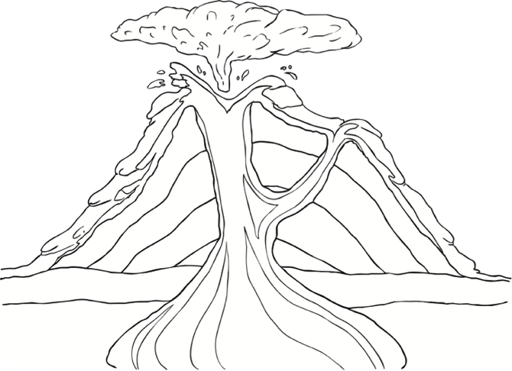
1

Magma Chamber Lava Crater Conduit/ Main Vent Eruption Cloud
4.
3.

