Oranges

**Homophones**

berry

bury

brake

break

meet

meat

ball

bawl

fair

fare

Due – Friday 15th January 2021



Pears

**Homophones**

here

hear

heel

heal

main

mane

mail

male

knot

not

Due – Friday 15th January 2021

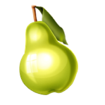



Apples

**(Near) Homophones**

quite

quiet

bare

bear

one

won

son

sun

whole

hole

Due – Friday 15th January 2021



Pineapples

the

and

a

to

said

Due – Friday 15th January 2021