**
Please use the grid method to calculate the following questions.
Use the PowerPoint from our Teams session to help you if you would like to go back and have another look at the method.

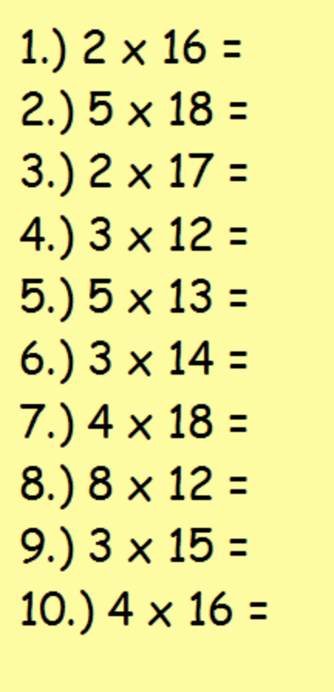

** ANSWERS
- 2 x 16 = 32
- 5 x 18 = 90
- 2 x 17 = 34
- 3 x 12 = 36
- 5 x 13 = 65
- 3 x 14 = 42
- 4 x 18 = 72
- 8 x 12 = 96
- 3 x 15 = 45
- 4 x 16 = 64

