Pompeii and the Eruption of Mount Vesuvius
Imagine you are safely across the bay when Vesuvius erupts.
What can you see?
What can you hear?

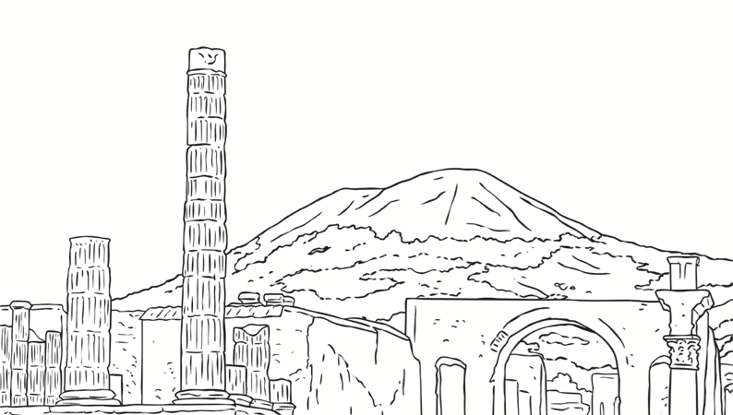
What can you smell?
What can you feel?

