Monday 11th January 2021

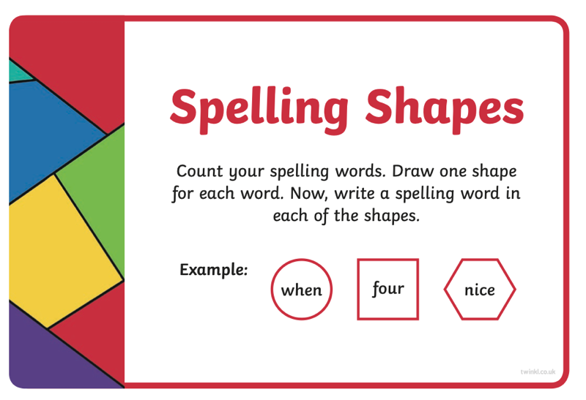
Spellings

