Guided reading homework- Blackman
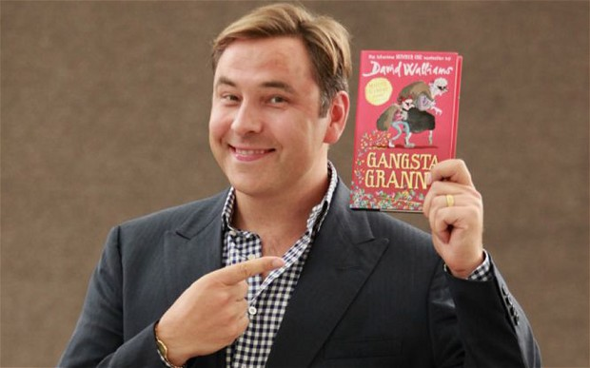
Please read to chapter 14
- What does it mean by “Hours passed by in what seemed like minutes”?
- Which of Granny’s tales do you think is the most amazing? Explain why.
- Can you find a word in this chapter that means “confused”?
- Even though Granny’s tales were unbelievable, he believed her. Why?
- Why do you think “a shiver ran down his spine”?
Pre-read chapter 14
How do you feel about Mr Parker? Do you like him as a character?

