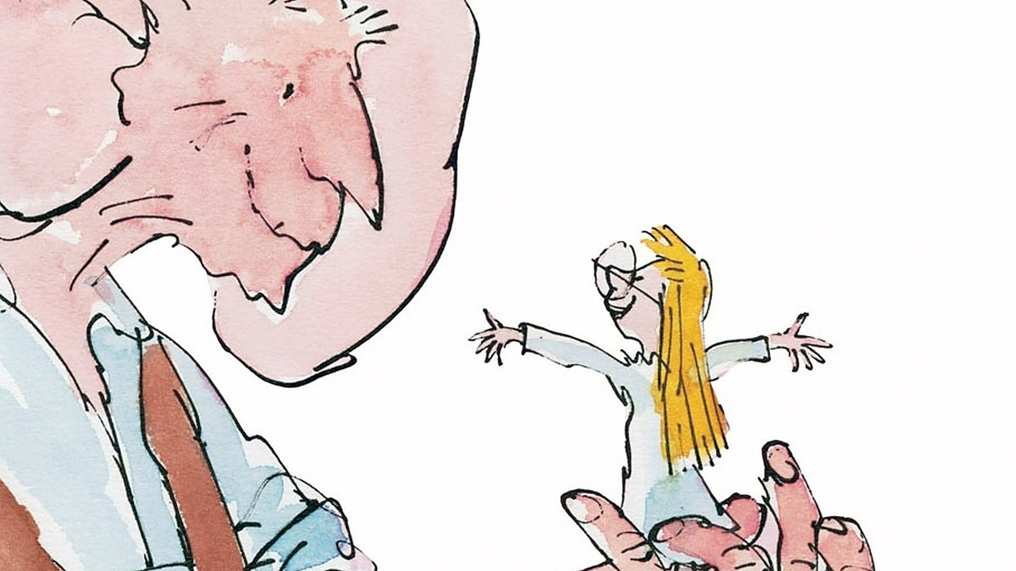
Guided reading homework- DiCamillo
Please read up to page 12. The answers to these questions can be found in “The Snatch”.
- What does it mean by “her blood turned to ice”?
- Why does “Giant” have a capital letter?
- Page 11- Can you find any evidence that tells you the giant was big?
- Why are there some words in italics?
- Can you choose 2 bits of description that you particularly like and explain why you like it?
Pre-read
Please read “The Cave”. If you were Sophie, what would your plan be?

