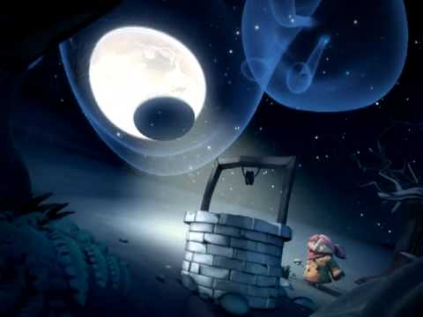Lune et L’autre

Frightened by the forest noises, the young girl, with beautiful auburn hair, quickly placed her bucket into the ancient well. Mysterious shadows crept slowly across the frosty ground as an owl hooted loudly. The icy wind whirled around her ears; the leafless trees danced wildly. Deep down in the cavernous well, the metal pail filled with cool water. Firmly planting her frozen feet in the glistening ground, the eager child hauled and heaved the tattered and worn rope until the shiny handle of the bucket appeared, illuminated by the moonlight, over the lip of the well.